# Overview

This document contains the necessary information to build the device.

Contents

Overview 1

Maker Checklist 3

Maker To Do List 3

Items to Give to User 3

Tool List 4

Custom PCB Guide 4

Ordering the Controller PCB 4

Ordering the Sensor PCB 4

Customization Guide 5

3D Printing Guide 6

3D Printing Summary 6

3D Printing Settings 6

Post-Processing 7

Examples of Quality Prints 7

Twitch Switch Controller Bottom 3D Print 7

Twitch Switch Controller Top 3D Print 7

Twitch Switch Controller Power Switch 3D Print 7

Twitch Switch Controller Knob 3D Print 8

Twitch Switch Sensor Bottom 3D Print 8

Twitch Switch Sensor Tops (1-3) 3D Prints 8

Assembly Guide 9

Part A: Twitch Switch Controller Assembly 9

Part A: Components 9

Part A: Tools 11

Part A: Personal Protective Equipment (PPE) 11

Part A: Twitch Switch Controller Assembly Steps 12

Part B: Flashing Firmware to Controller 25

Part B: Components 25

Part B: Tools 25

Part B: Controller Firmware Flashing Steps 25

Part C: Twitch Switch Sensors Assembly 28

Part C: Components 28

Part C: Tools 29

Part C: Personal Protective Equipment (PPE) 29

Part C: Twitch Switch Controller Assembly Steps 30

Part D: Build Programmer for Flashing Sensor Firmware 34

Part D: Components 34

Part D: Programmer Assembly Steps 35

Part E: Flashing Firmware to Sensors 38

Part E: Components 38

Part E: Tools 38

Part E: Sensor Firmware Flashing Steps 38

Testing 42

Required Components for Testing 42

Testing the Twitch Switch 42

Testing Mode LED and Device Power 42

Testing 3.5 mm Jacks 42

Test USB Connection 42

Test Bluetooth Connection 42

# Maker Checklist

This list provides an overview of the steps required to build and deliver the device.

## Maker To Do List

* Read through the Assembly Guide to become familiar with required components, tools, supplies, and safety gear and overall assembly steps.
* Talk to User about customization options (e.g., color, any special requests, etc.).
* Ask User what colour they would like their Twitch Switch Controller to be.
* Ask User what colour they would like their Twitch Switch Sensors to be.
* Order hardware components.
* Gather tools, supplies, and safety equipment.
* Assemble the device.
* Test device.
* Print User Guide.

## Items to Give to User

* Assembled, tested device
* User Guide.
* Micro-USB cable (for Controller).
* Mini-USB cable (for Sensors).

# Tool List

|  |  |
| --- | --- |
| * Fine-tipped soldering iron * Solder * Flush cutters * Breadboard or small clamp * CP2102 Programmer | * Solderless breadboard * Micro-USB Cable * Mini-USB Cable * Audio cable (for testing) * Switch Tester (for testing) |

# Custom PCB Guide

The Twitch Switch uses two different custom circuit boards: 1 for the controller and 1 for the sensor. The sensor boards are intended for PCB-A (i.e., the PCB Fabrication company will populate the surface mount components onto the board.)

The Custom PCB can be ordered from one of a variety of PCB Manufacturers. Typically, the minimum quantity for a custom PCB is five. Shipping options vary significantly in cost and shipping time. Plan on at least a week from the time of order to the PCBs arrival.

## Ordering the Controller PCB

1. Select a PCB Fabrication Company
   1. [JLPCB](https://jlcpcb.com/)
   2. [PCBWay](https://www.pcbway.com/)
   3. [OSH Park](https://oshpark.com/)
   4. [Seeed Fusion PCB](https://www.seeedstudio.com/fusion_pcb.html)
2. Create an account or use a guest login.
3. Upload the Gerber Files.
4. Select the fabrication options:
   1. PCB Layers: 2 Layers
   2. PCB Quantity: 5
   3. PCB Thickness: 1.5 mm
   4. Surface Finish: HASL
   5. PCB Color: Choose what you like. Note that certain colors may impact build time.
   6. The default settings for the other settings should work.
5. Select shipping option.
   1. Shipping options and costs vary significantly. Select the best option based on your budget and timing.
6. Submit the order.

## Ordering the Sensor PCB

# Customization Guide

The controller can be printed in the user’s desired colour.

The sensors can be printed in the user’s desired colour.

A colour swap can be done to add contrast to the labels on the top.

Contrasting colours can be chosen for the knobs and slide switch so they can be seen more easily.

# 3D Printing Guide

## 3D Printing Summary

|  |  |  |  |
| --- | --- | --- | --- |
| **Metrics** | **Twitch Switch Controller** | **Twitch Switch Sensors (3)** | **Twitch Switch Complete Set** |
| Total Print Time (hr:min) | 5:11 | 2:39 | 7:50 |
| Total Number of Components | 3 | 6 | 9 |
| Typical Total Mass (g) | 42.7 | 21.9 | 64.6 |
| Typical Number of Print Setups | 1 | 1 | 1 |

## 3D Printing Settings

Table 1: Twitch Switch Controller Print Settings

|  |  |  |  |  |  |  |  |
| --- | --- | --- | --- | --- | --- | --- | --- |
| **Print File Name** | **Qty** | **Total Print Time (hr:min)** | **Mass (g)** | **Infill (%)** | **Support (Y/N)** | **Layer Height/ Nozzle Diameter(mm)** | **Notes** |
| Twitch_Switch_ Controller_Bottom_v3 | 1 | 2:11 | 19.8 | 20 | N | 0.2/0.4 |  |
| Twitch_Switch_ Controller_Top_v3 | 1 | 2:13 | 19.6 | 20 | N | 0.2/0.4 |  |
| Twitch_Switch_ Controller_Power_ Switch_v3 | 1 | 0:05 | 0.3 | 20 | N | 0.2/0.4 |  |
| Twitch_Switch_ Controller_Knob_v3 | 3 | 0:14 | 1 | 20 | N | 0.2/0.4 |  |

Table 2: Twitch Switch Sensors Print Settings

|  |  |  |  |  |  |  |  |
| --- | --- | --- | --- | --- | --- | --- | --- |
| **Print File Name** | **Qty** | **Total Print Time (hr:min)** | **Mass (g)** | **Infill (%)** | **Support (Y/N)** | **Layer Height/ Nozzle Diameter(mm)** | **Notes** |
| Twitch_Switch_ Sensor1_Top_v3 | 1 | 0:19 | 2.7 | 20 | N | 0.2/0.4 |  |
| Twitch_Switch_ Sensor2_Top_v3 | 1 | 0:19 | 2.7 | 20 | N | 0.2/0.4 |  |
| Twitch_Switch_ Sensor3_Top_v3 | 1 | 0:19 | 2.7 | 20 | N | 0.2/0.4 |  |
| Twitch_Switch_ Sensor_Bottom_v3 | 3 | 0:34 | 4.6 | 20 | N | 0.2/0.4 |  |

## Post-Processing

* Remove any stringing or blobs

## Examples of Quality Prints

**Photo of Device**

### Twitch Switch Controller Bottom 3D Print

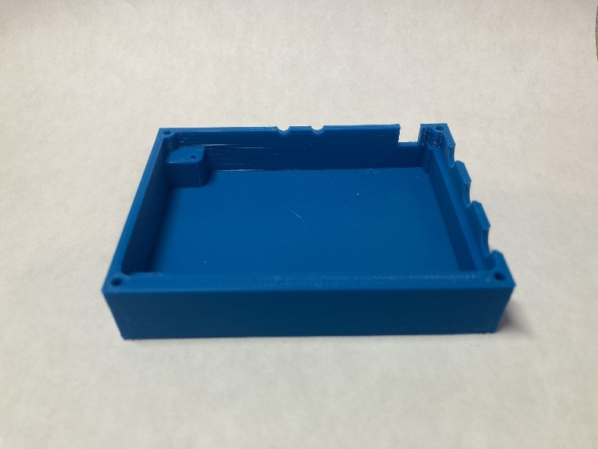 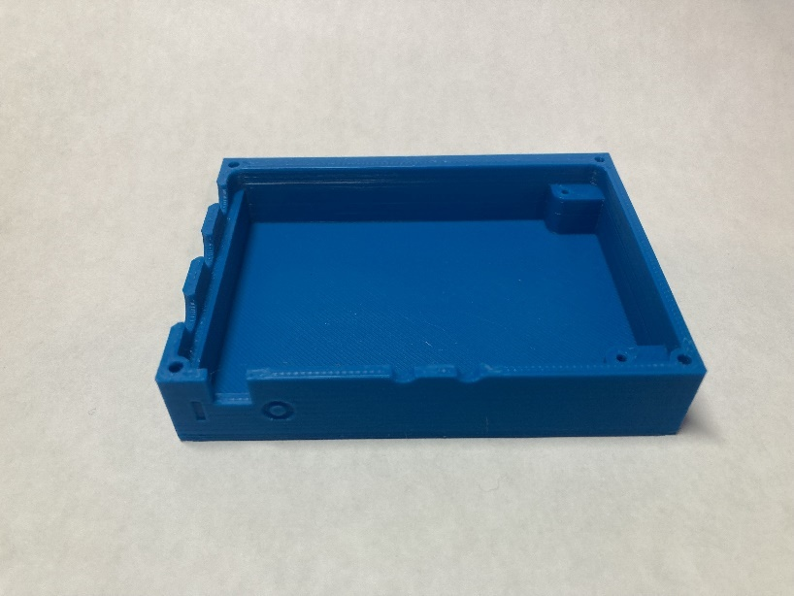

### Twitch Switch Controller Top 3D Print

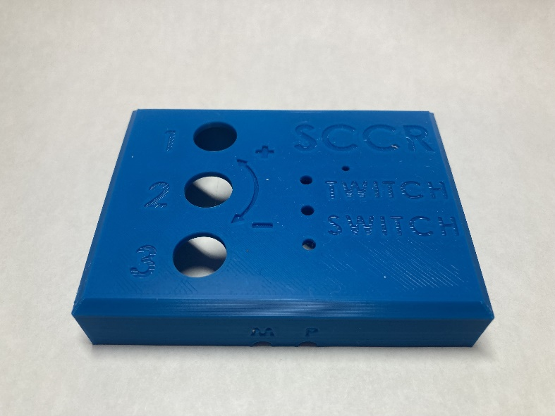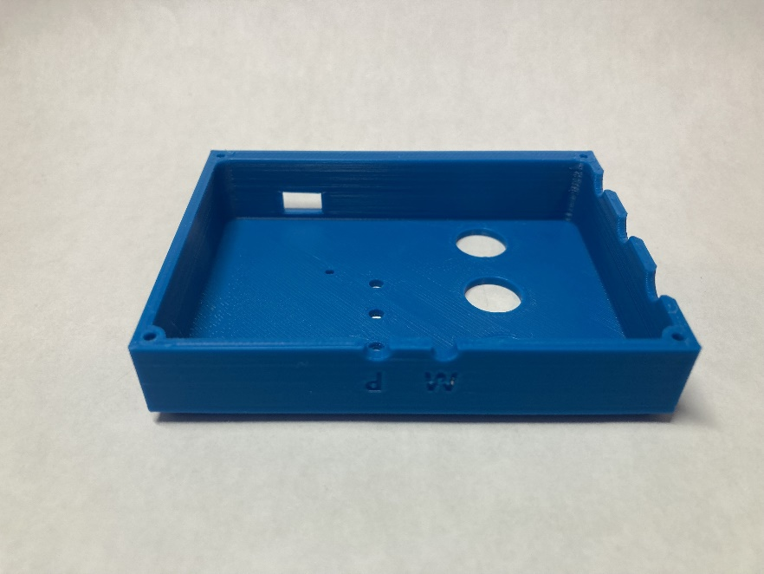

### Twitch Switch Controller Power Switch 3D Print

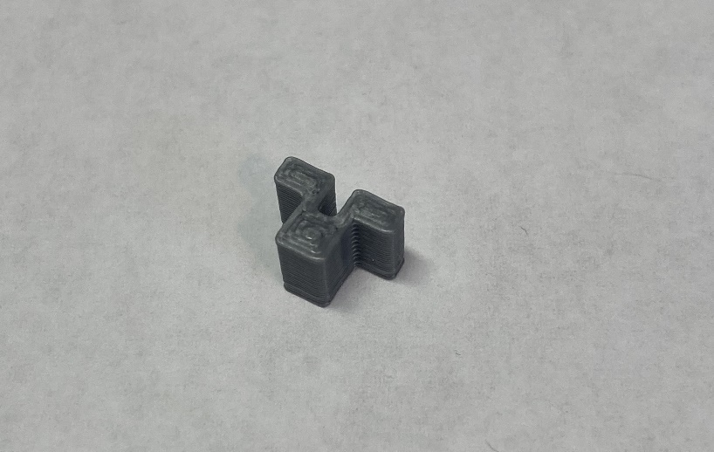

### Twitch Switch Controller Knob 3D Print

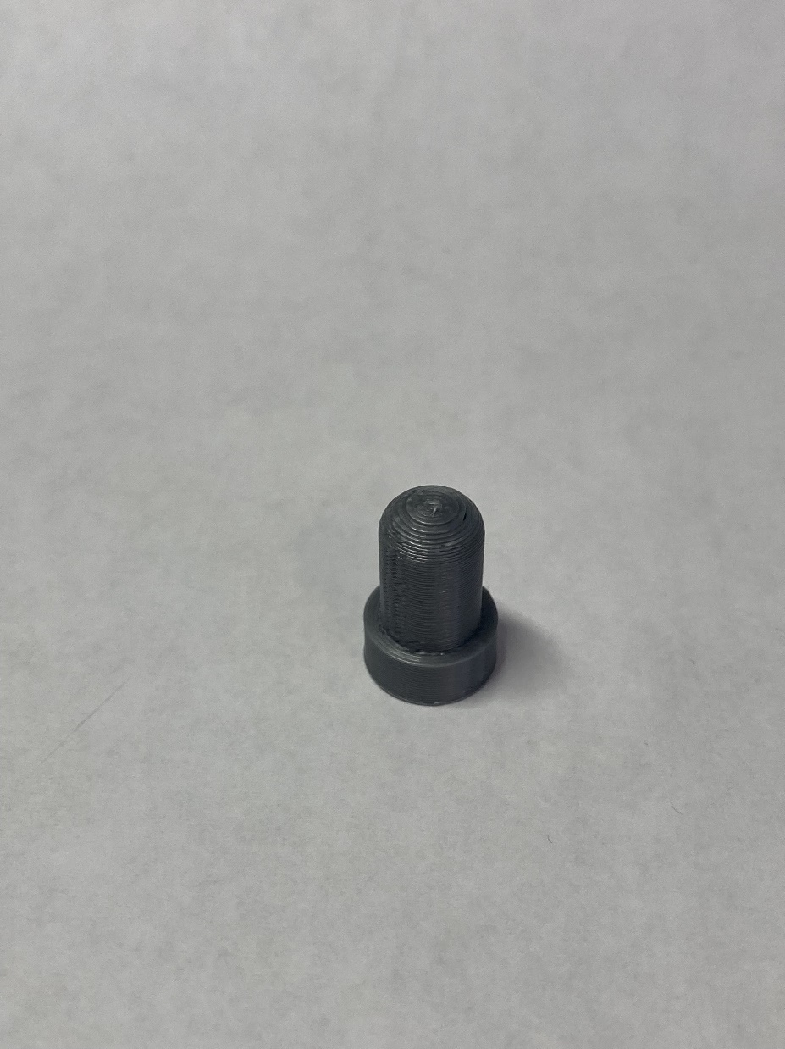 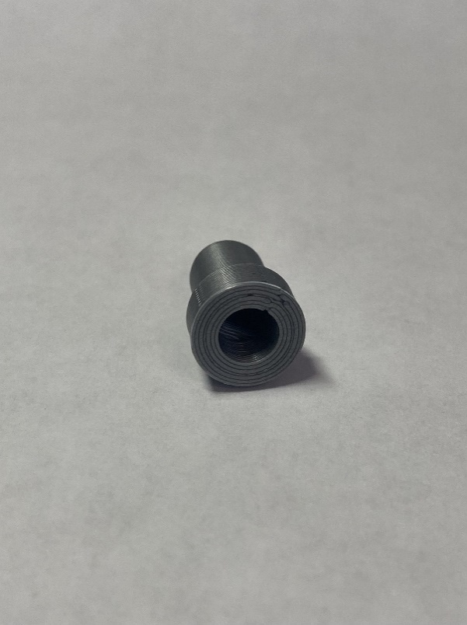

### Twitch Switch Sensor Bottom 3D Print

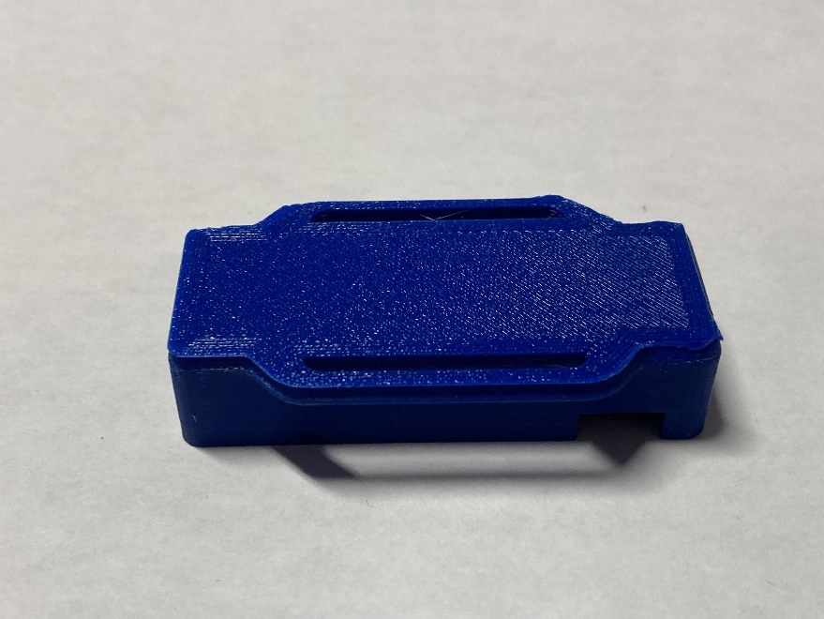 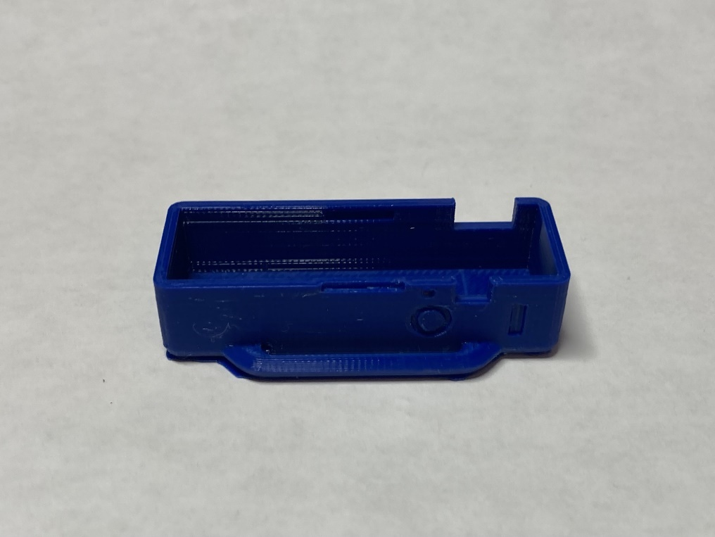

### Twitch Switch Sensor Tops (1-3) 3D Prints

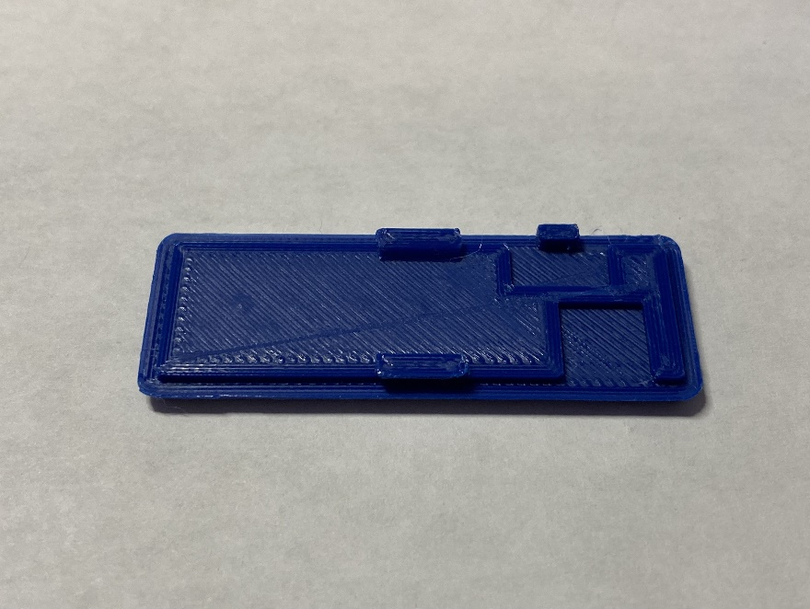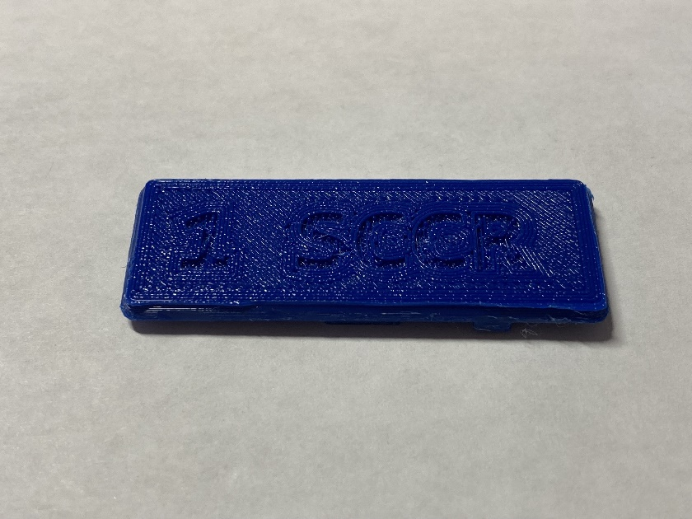

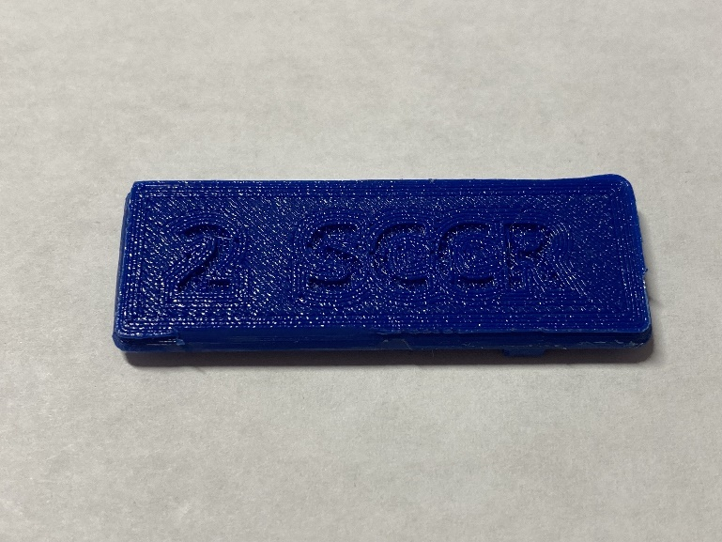 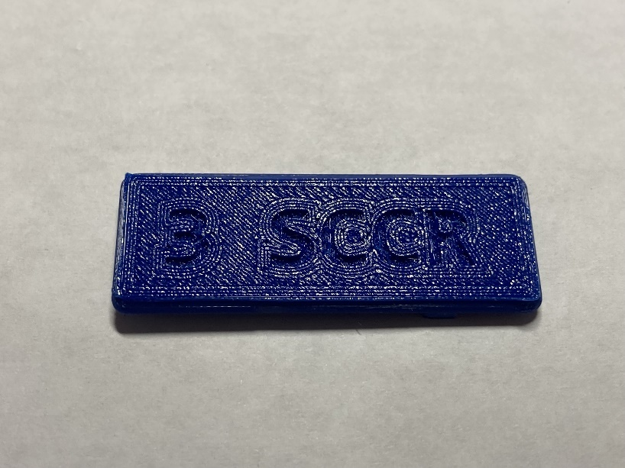

# Assembly Guide

## Part A: Twitch Switch Controller Assembly

### Part A: Components

|  |  |  |  |  |  |  |  |  |
| --- | --- | --- | --- | --- | --- | --- | --- | --- |
| **A01** | Blank PCB - Twitch Switch Controller | QTY 1 | **A02** | Adafruit Feather Board | QTY 1 | **A03** | Power switch | QTY 1 |
|  | | |  | | |  | | |
| **A04** | 3.5 mm Jack | QTY 3 | **A05** | Solid-state relay | QTY 3 | **A06** | 330 Ω resistor | QTY 3 |
|  | | | フォトカプラ フォトリレー 60V0.5A TLP222AF | | |  | | |
| **A07** | Dial | QTY 3 | **A08** | Radio | QTY 1 | **A09** | 680Ω resistor | QTY 3 |
|  | | |  | | |  | | |

|  |  |  |  |  |  |  |  |  |
| --- | --- | --- | --- | --- | --- | --- | --- | --- |
| **A10** | 8 mm Light tubes | QTY 3 | **A11** | Red LEDs | QTY 3 | **A12** | Push button | QTY 2 |
|  | | |  | | |  | | |
| **A13** | 12- and 16-pin male headers | QTY 1 | **A14** | 12- and 16-pin female headers | QTY 1 | **A15** | 3.7V 2000mAh lithium-ion polymer battery | QTY 1 |
|  | | |  | | |  | | |
| **A16** | 3D-printed Twitch Switch Controller Case | QTY 1 | **A17** | 3D-printed switch cover | QTY 1 | **A18** | 3D-printed dial covers | QTY 3 |
|  | | |  | | |  | | |
| **A19** | 6.5 cm x 5 cm insulating foam | QTY 1 | **A20** | M2 x 0.4mm x 5mm screws | QTY 2 | **A21** | M2 x 0.4 mm x 25mm screws | QTY 1 |
|  | | |  | | |  | | |

### Part A: Tools

|  |  |  |
| --- | --- | --- |
| Fine-tipped soldering iron   |  | Flush Cutters   |
| Breadboard or small clamp   | Micro-USB cable   | Audio cable (for testing)  onn. 3 FT./91.4 cm 3.5 mm AUX Cable, Easy Connect |
|  |  |  |

### Part A: Personal Protective Equipment (PPE)

* Protective eyewear

### Part A: Twitch Switch Controller Assembly Steps

#### A green circuit board with a small metal piece Description automatically generatedStep 1: Insert and Solder the Power Switch

Begin with the **blank PCB (A01)** and **power switch (A03)**. At position ‘SW1’, apply a small dab of solder onto one of the three pads of the PCB as shown. **Tin** the bottoms of the leads of the power switch.

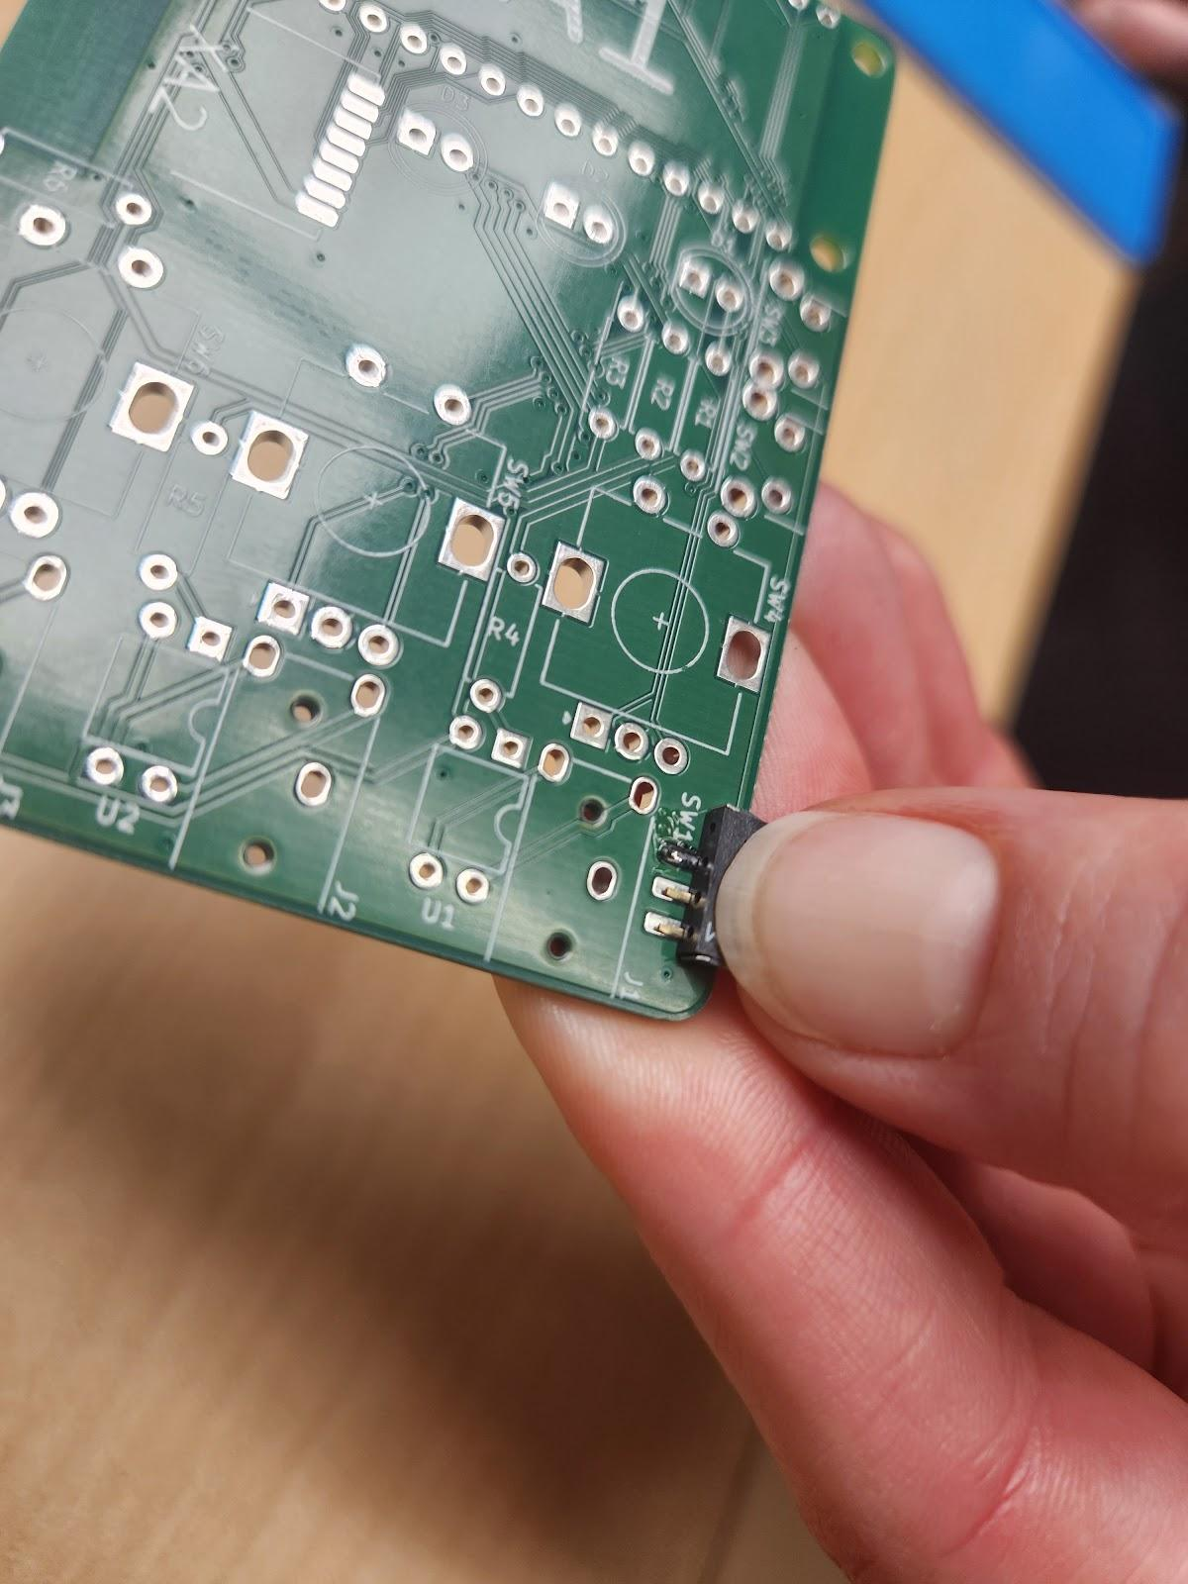Flip the power switch over and pinch the PCB and the power switch together. The “feet” of the power switch will be flush with the edge of the PCB. Solder the first lead to the PCB. This will secure the power switch in place.

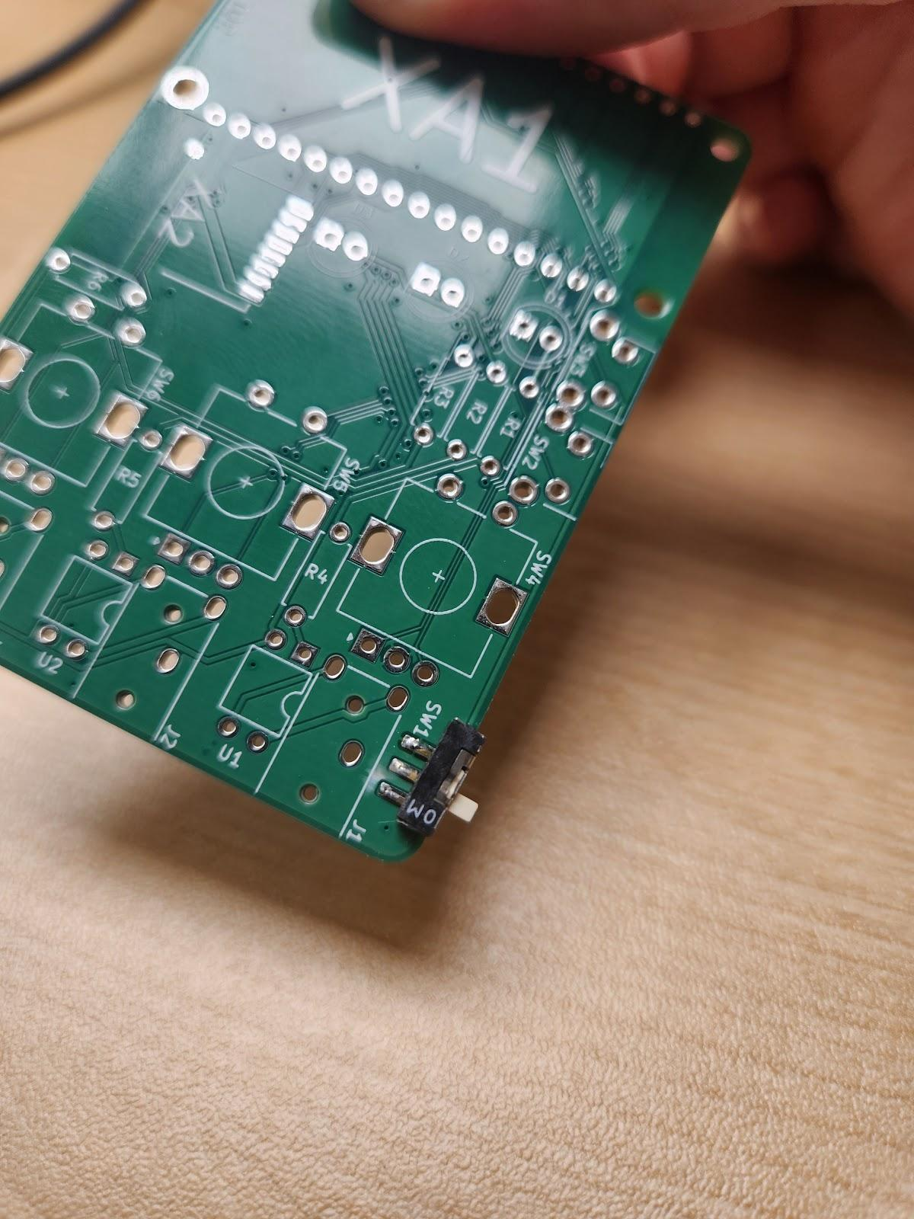Ensure the switch is still flush with the PCB before soldering the other two leads. If not, reheat the solder joint and reposition the switch.

Ensure soldering on each pad **doesn’t bridge.**

#### Step 2: Insert and solder the 3.5 mm Audio Jacks

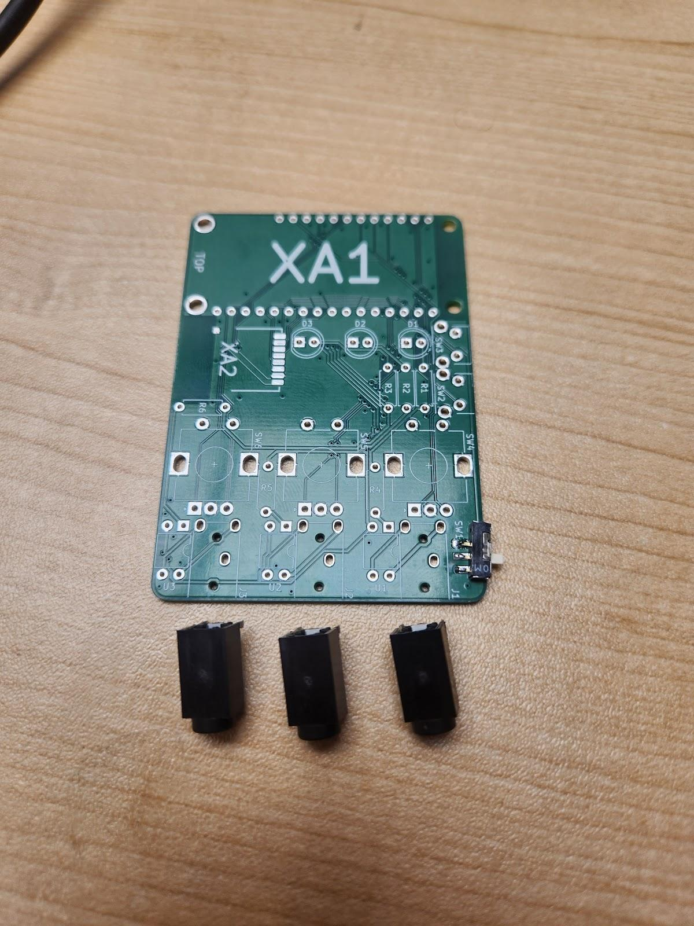

Insert the three **3.5 mm jacks (A04)** into positions ‘J1’, ‘J2’, and ‘J3’ and line up with the outlines on the blank PCB as shown.

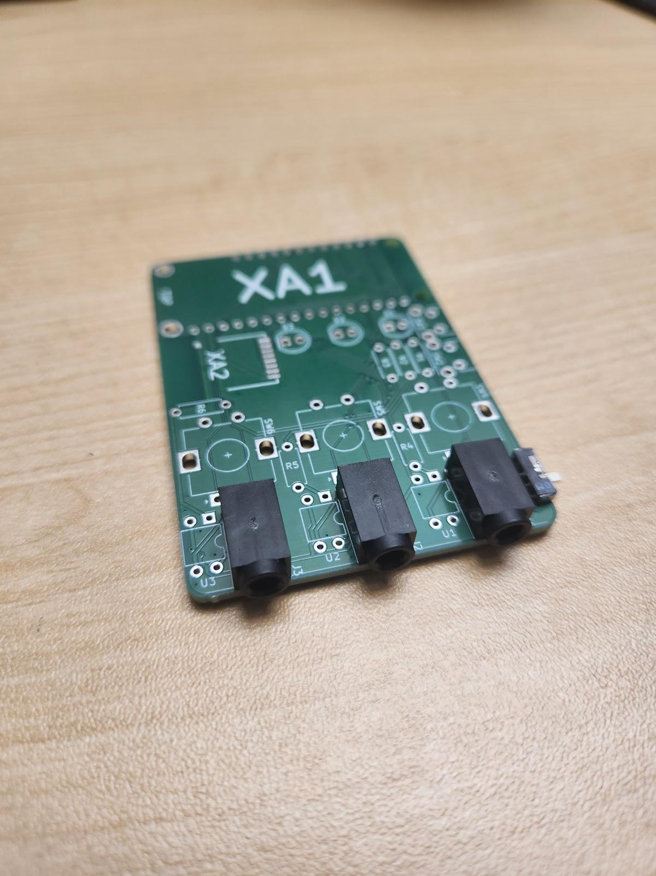

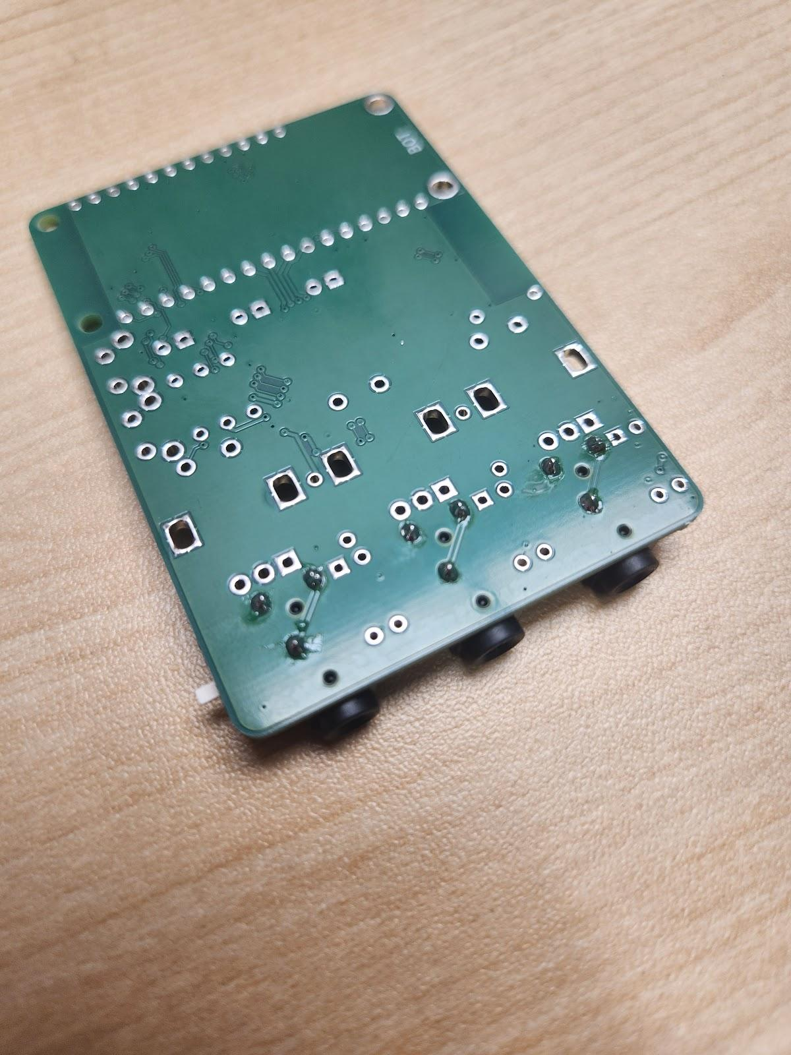

For each jack, flip the board over and solder one pin of the 3.5 mm jack in place, ensuring it stays flat and straight.

Check that the jack is straight and flat/flush to the board, if not reheat the solder joint and reposition.

Once properly positioned, solder the remaining 2 pins.

#### Step 3: Insert and Solder the Solid-State Relays

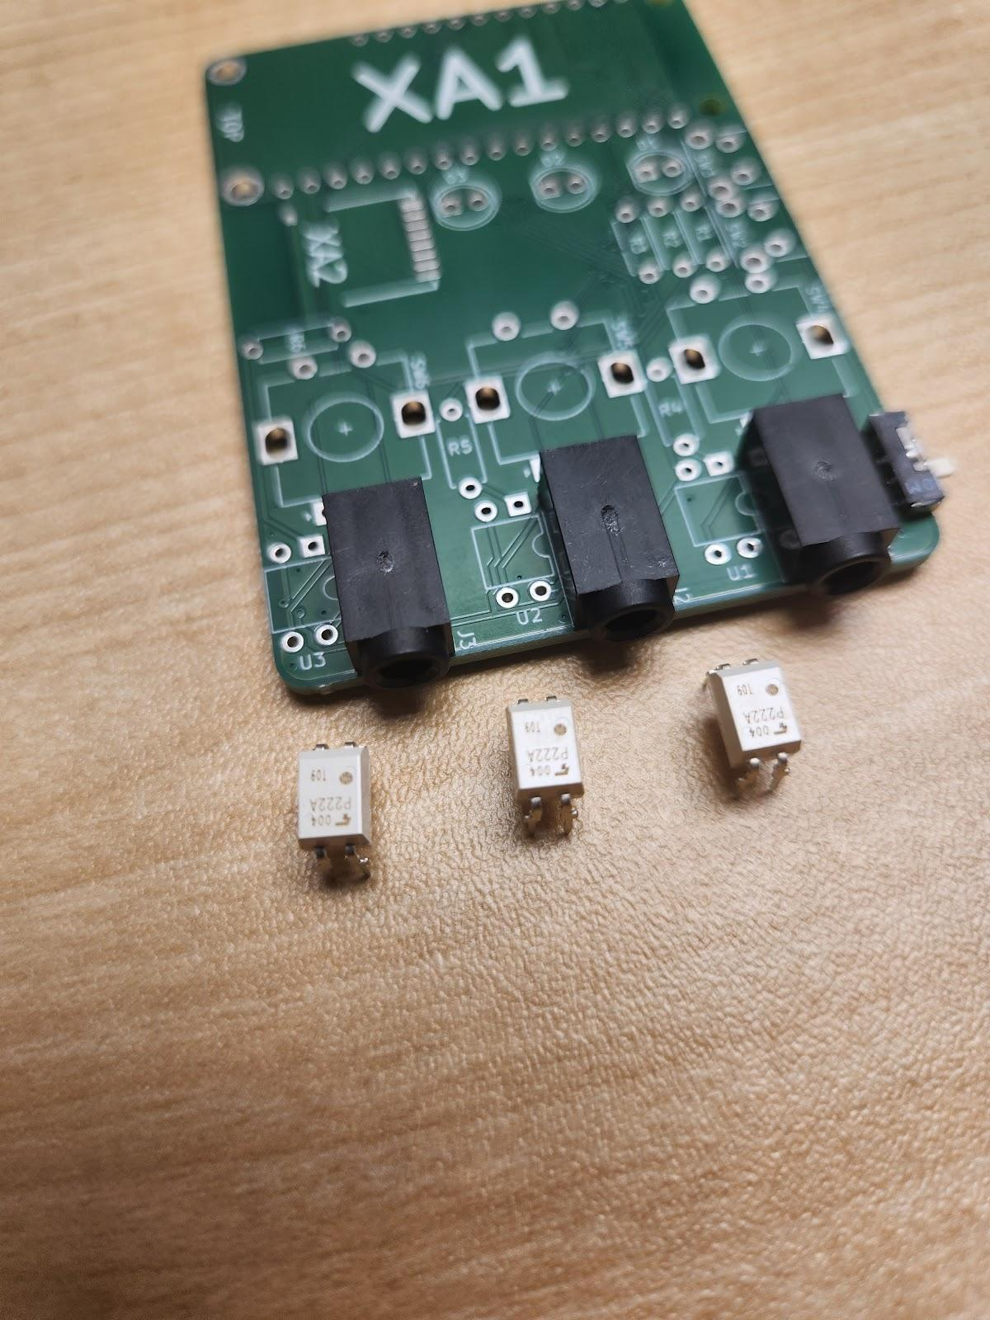Insert the three **solid-state relays (A05)** into positions ‘U1’, ‘U2’, and ‘U3’ on the PCB next to the 3.5 mm jacks as shown.

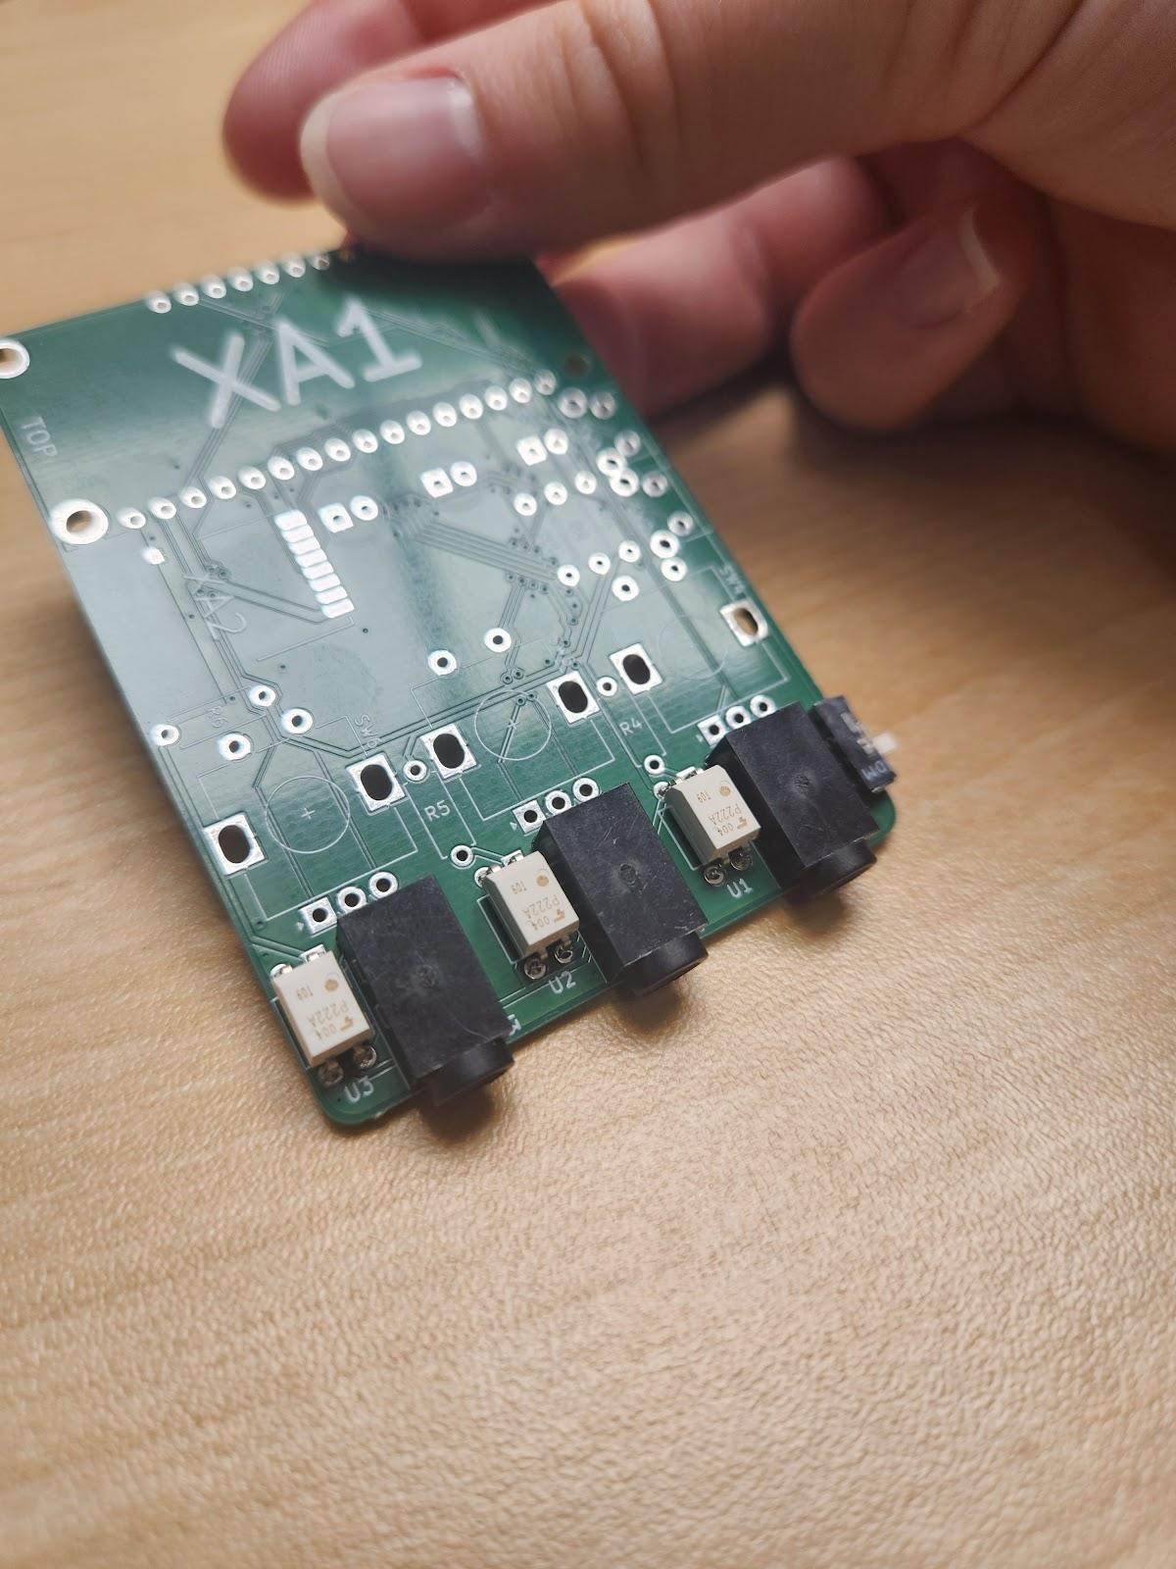Note that **orientation of the relays matters**. Ensure it matches the images shown, with the ‘dot’ on the relay oriented towards the ‘notch’ outlined on the board.

Flip the board over and solder the relays in place, ensuring they stay flat and straight.

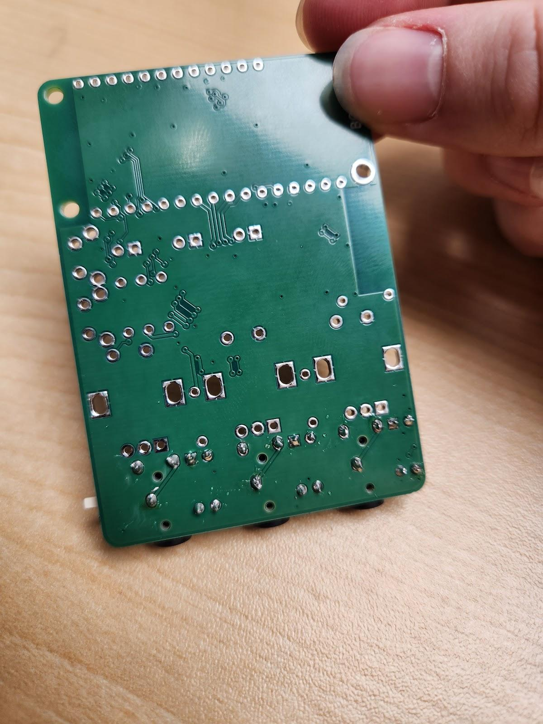

#### Step 4: Insert and Solder the 330Ω Resistors

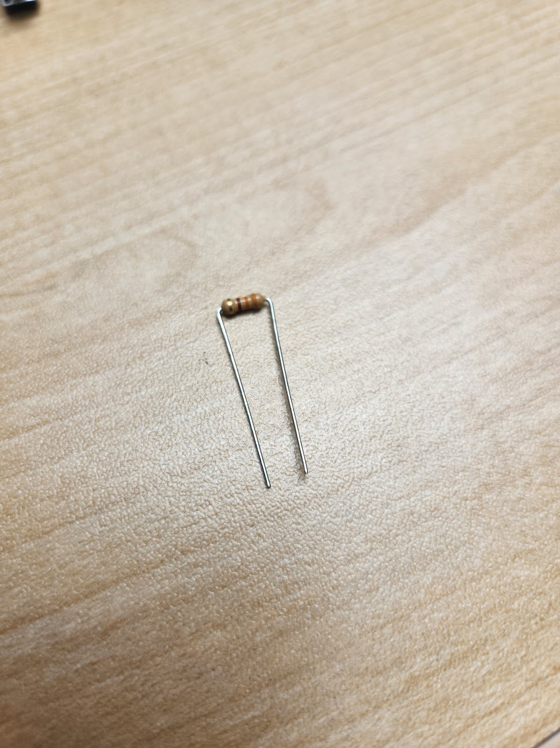Bend the three **330Ω resistors (A06)** into a U-shape.

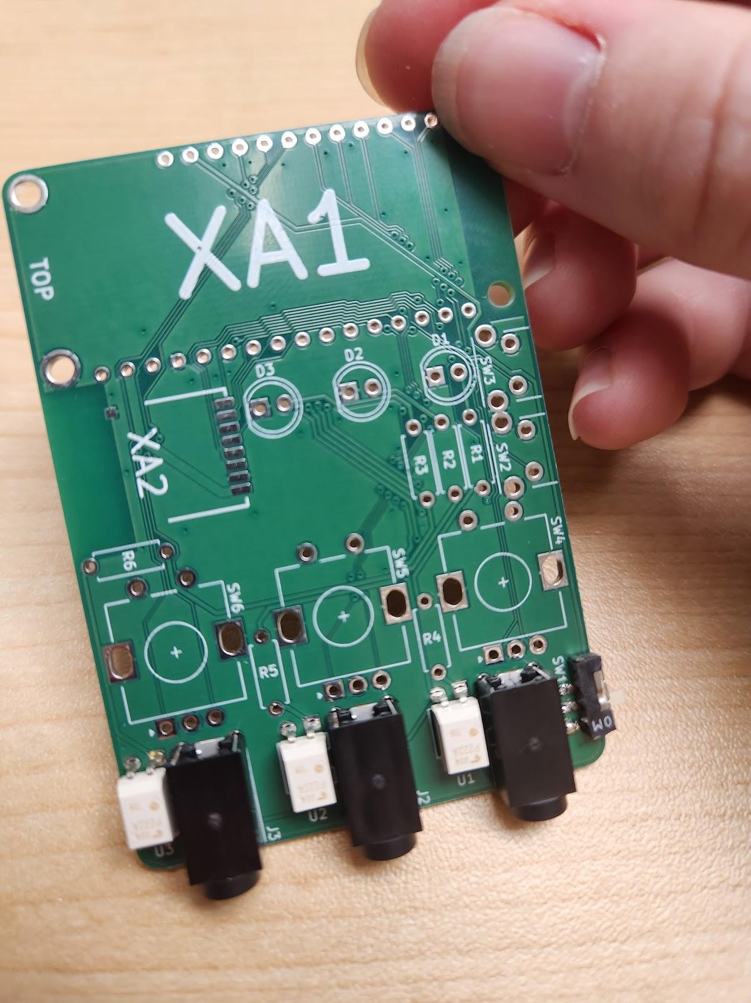Locate the outlines labeled ‘R4’, ‘R5’, and ‘R6’ on the PCB. Thread leads of the resistors through holes as shown. Orientation of the resistors **does not matter**.

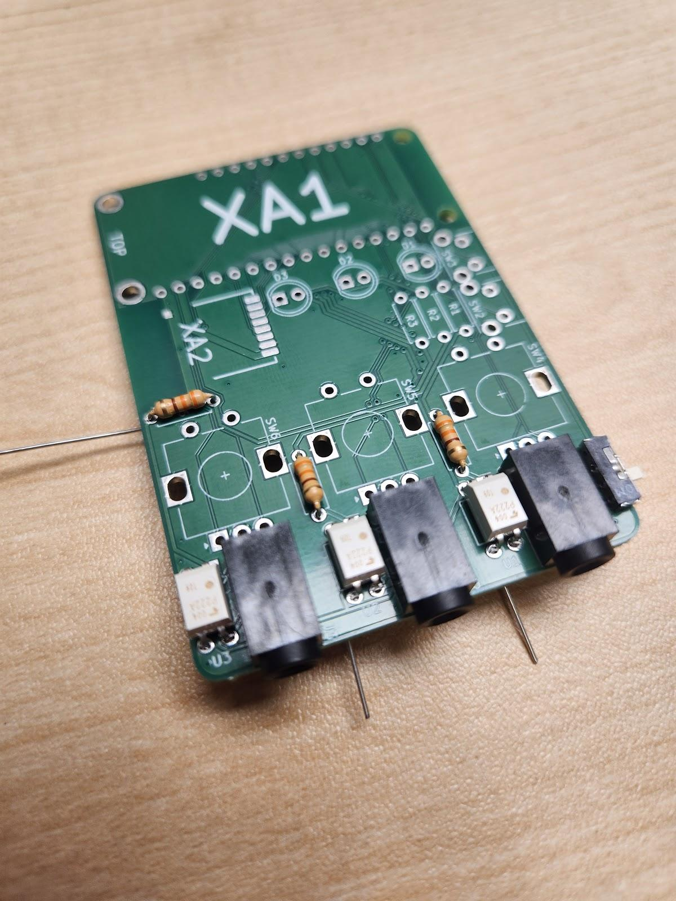

Flip the board over and solder the leads of the resistors in place, then trim the leads flush with the PCB.

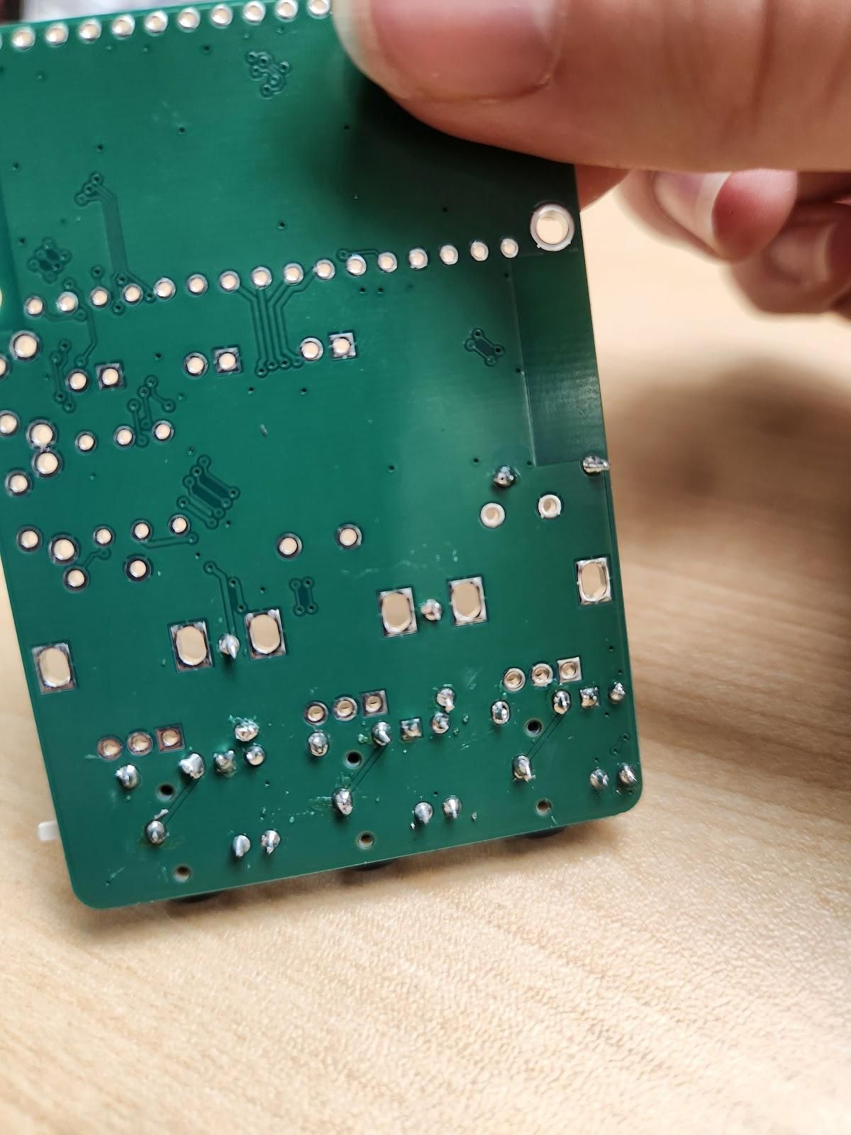

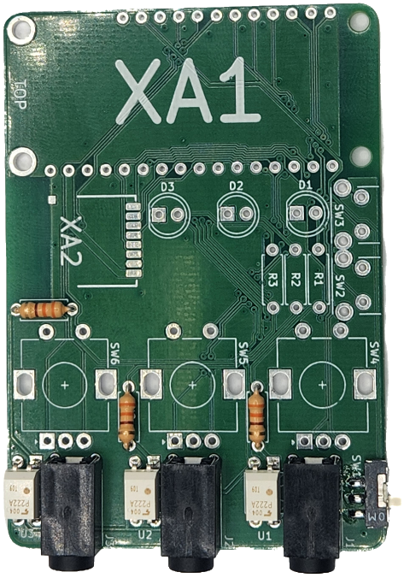Your board should now look like this:

#### Step 5: Insert and Solder the Dials

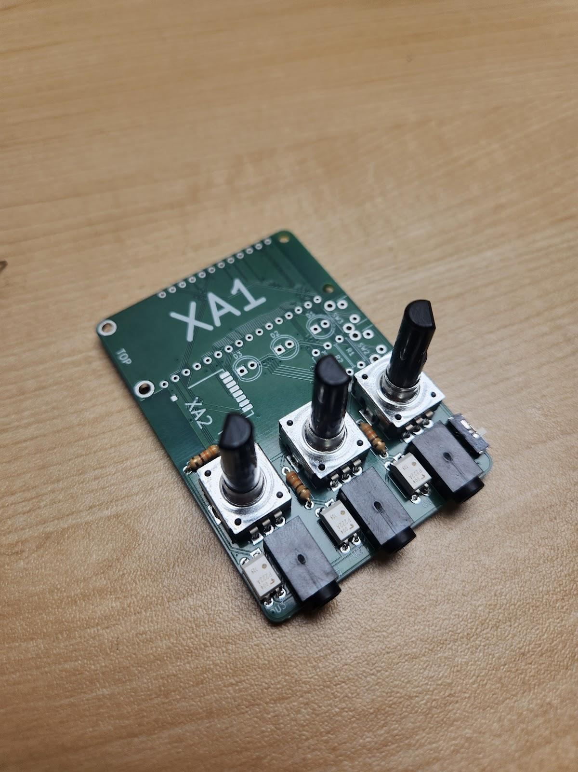Line up the **dials (A07)** into the positions ‘SW4’, ‘SW5’, and ‘SW6’ on the PCB as shown. They will only fit one way and will ‘snap’ into place.

Flip the board over and solder the dials in place. This includes the 5 pins as well as the 2 locking legs.

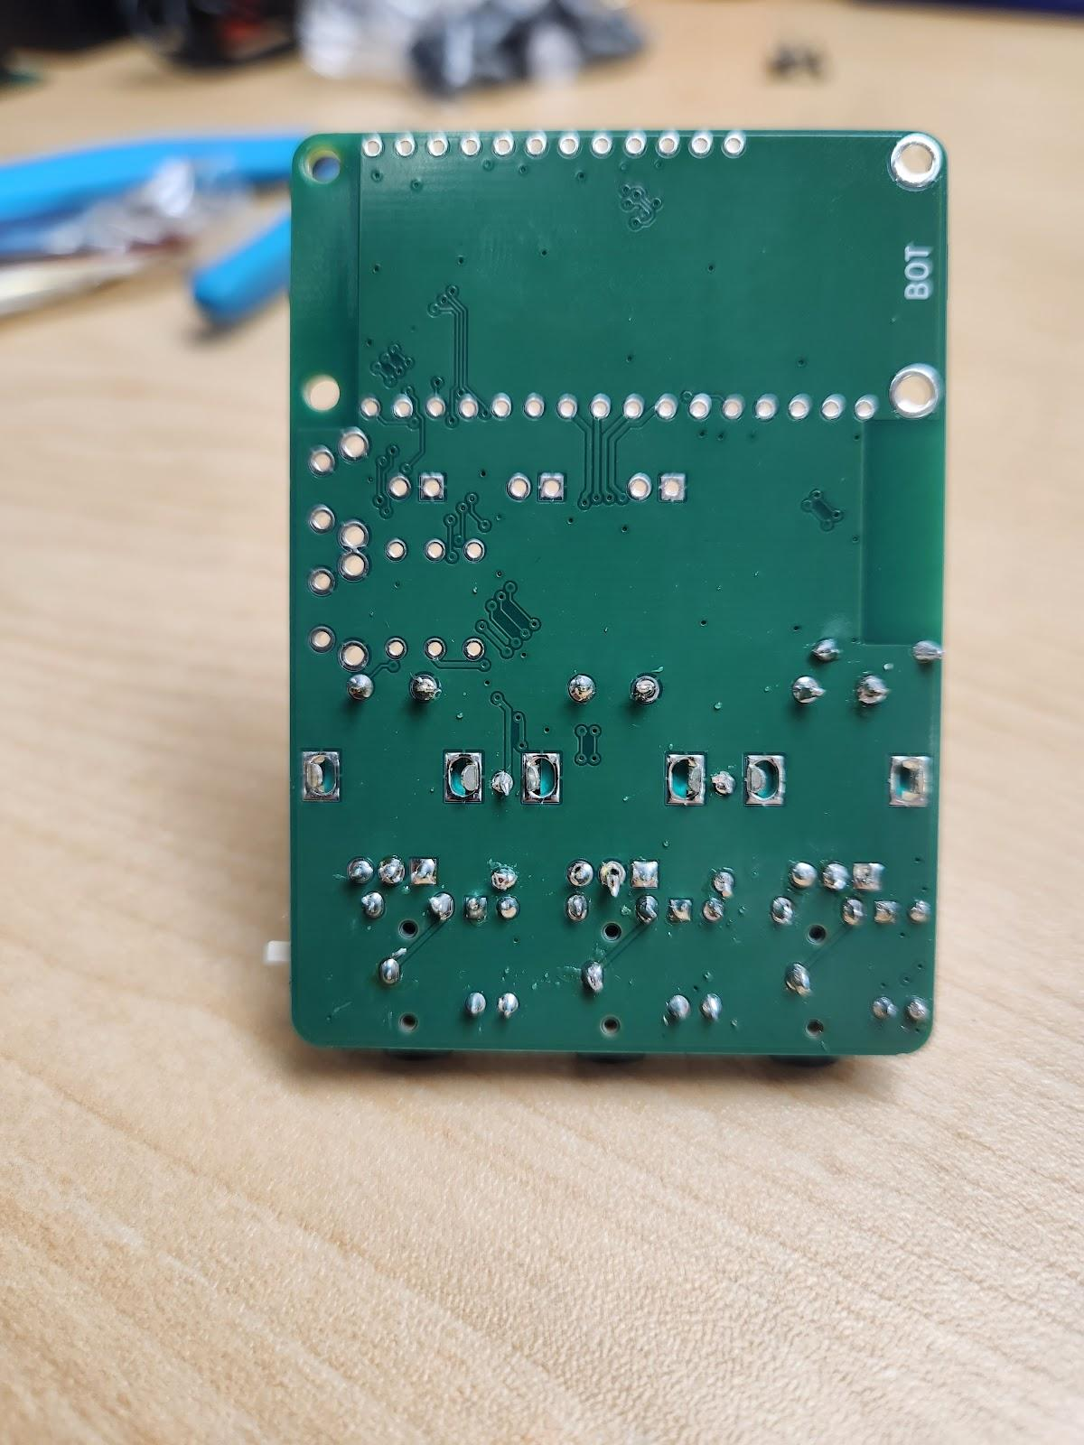

#### Step 6: Position and Solder the Radio

On the PCB, locate the outline labeled ‘XA2’. Apply a dab of solder onto one of the pads.

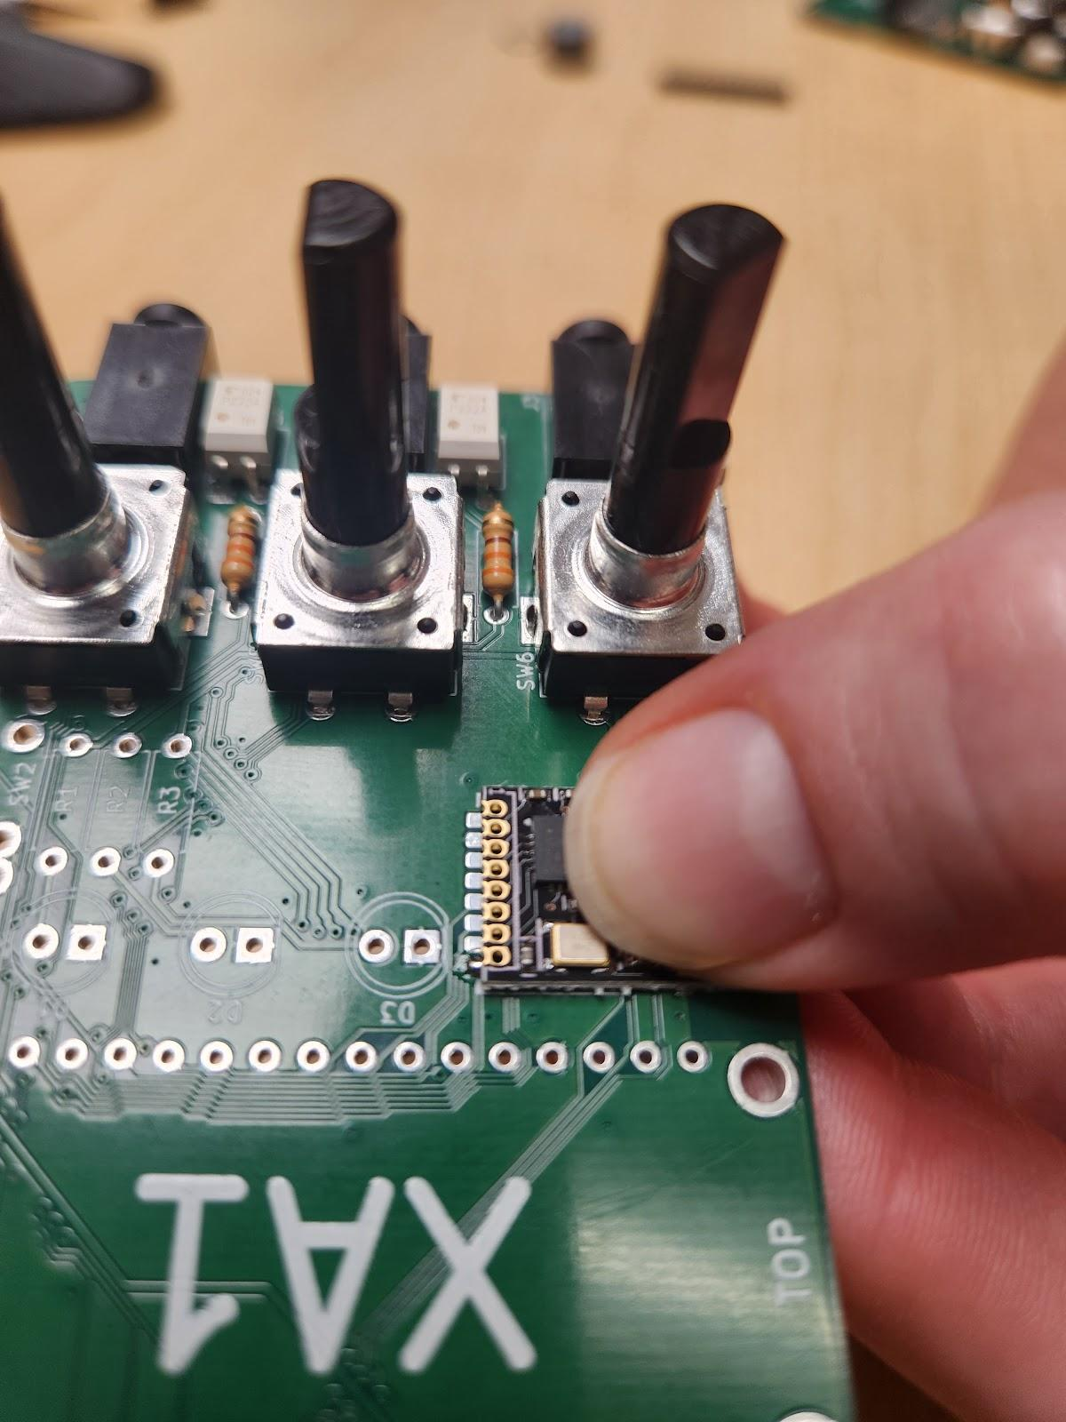

Pinch the **radio (A08)** and the PCB together so that the pads of the radio and PCB partially overlap. Heat the dab of applied solder to secure the radio in place. **Ensure radio is still straight and flush with the PCB before continuing.** Ensure the pads of the radio line up with the pads on the PCB and aren’t offset, and that the edge of the radio lines up with the edge of the PCB and does not overhang.

Apply a dab of solder to the next pad of the radio. While still hot, draw the soldering down to the pad of the PCB so that the two connect. Repeat for each pad.

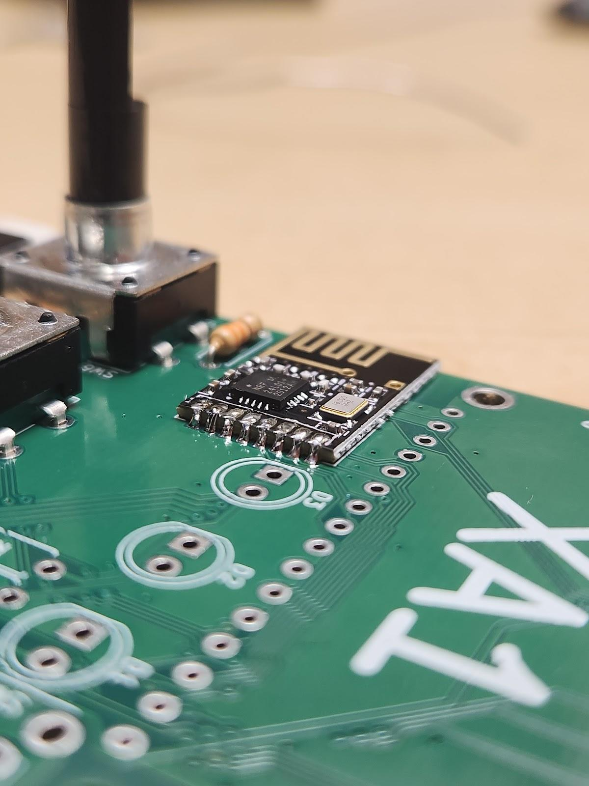Ensure the solder between each pad **doesn’t bridge**.

#### Step 7: Insert and solder the 680Ω resistors

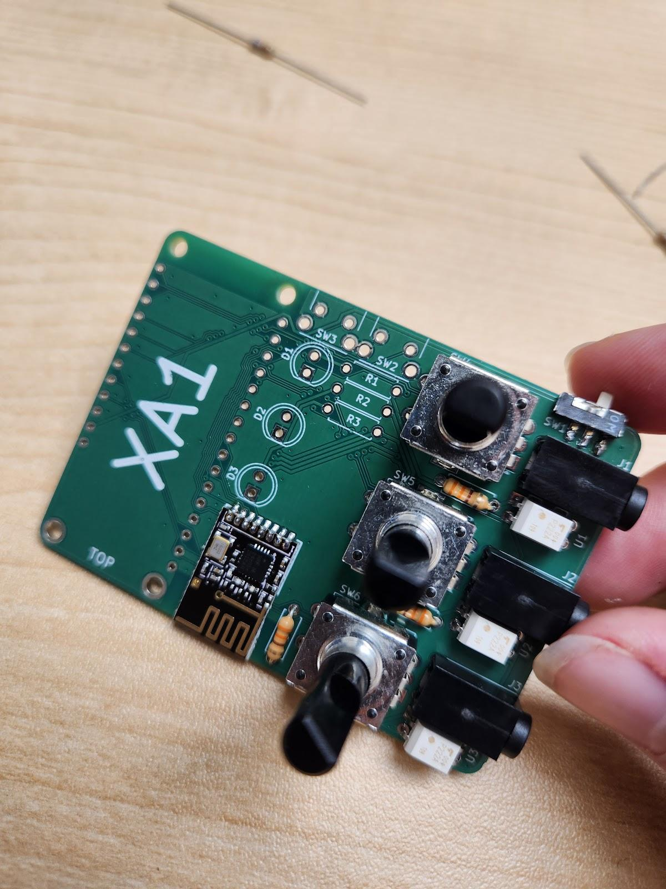Using the same process described in Step 4, bend the **680Ω resistors (A09)** into a U-shape.

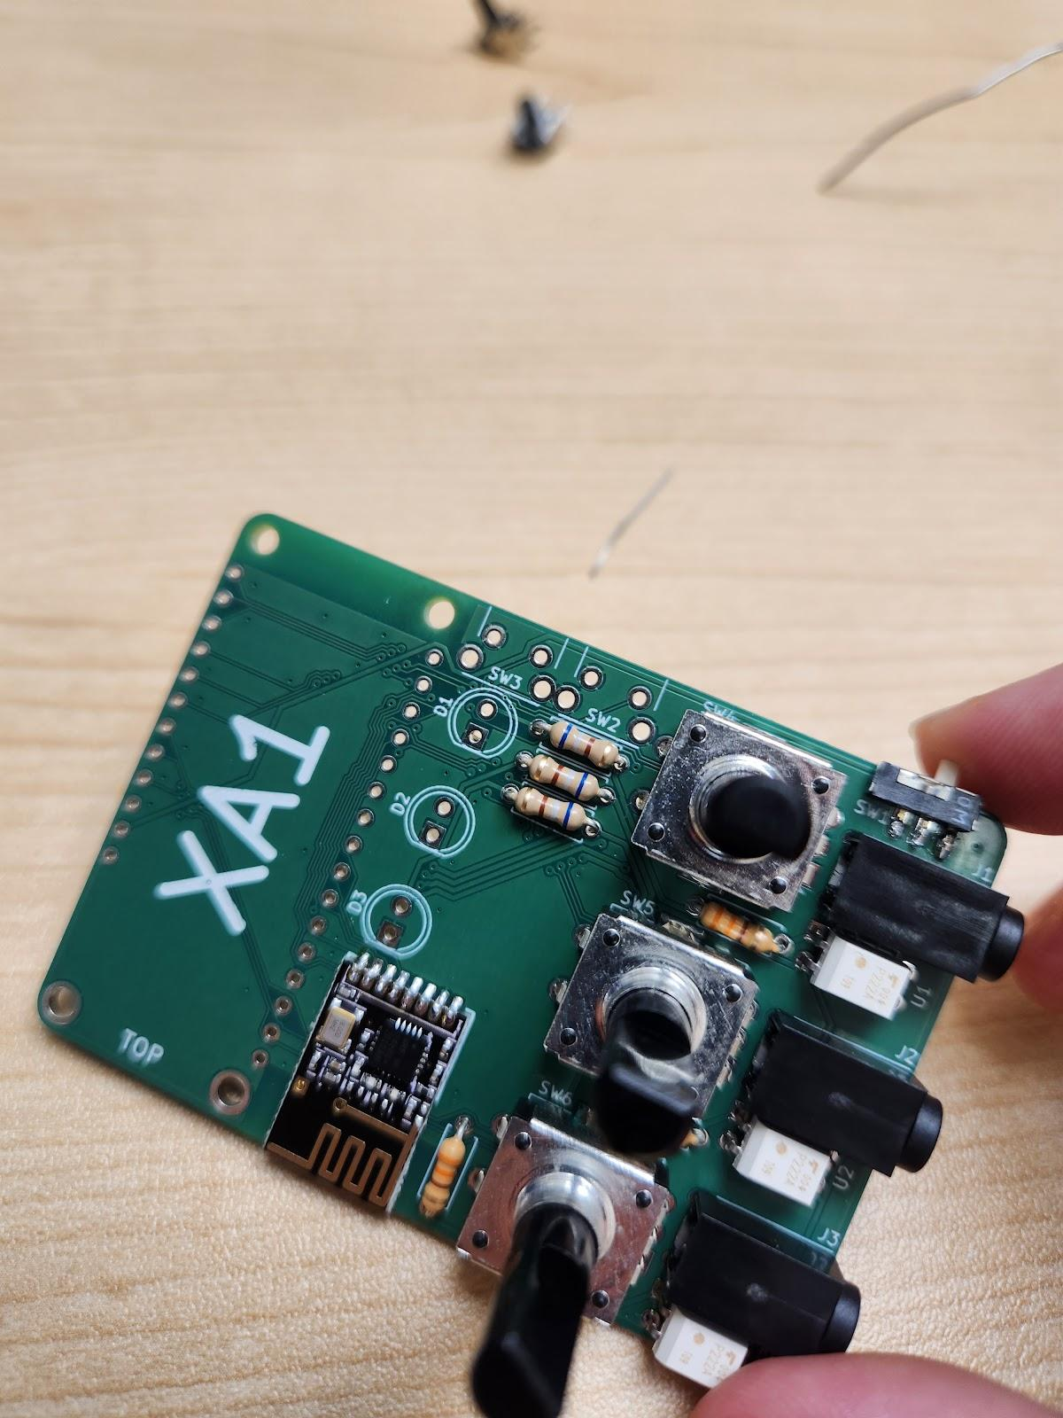Locate the outlines labeled ‘R1’, ‘R2’, and ‘R3’ on the PCB. Thread leads of the resistors through holes as shown. Orientation of the resistors **does not** matter.

Flip the board over and solder the leads of the resistors in place, then trim the leads flush with the PCB.

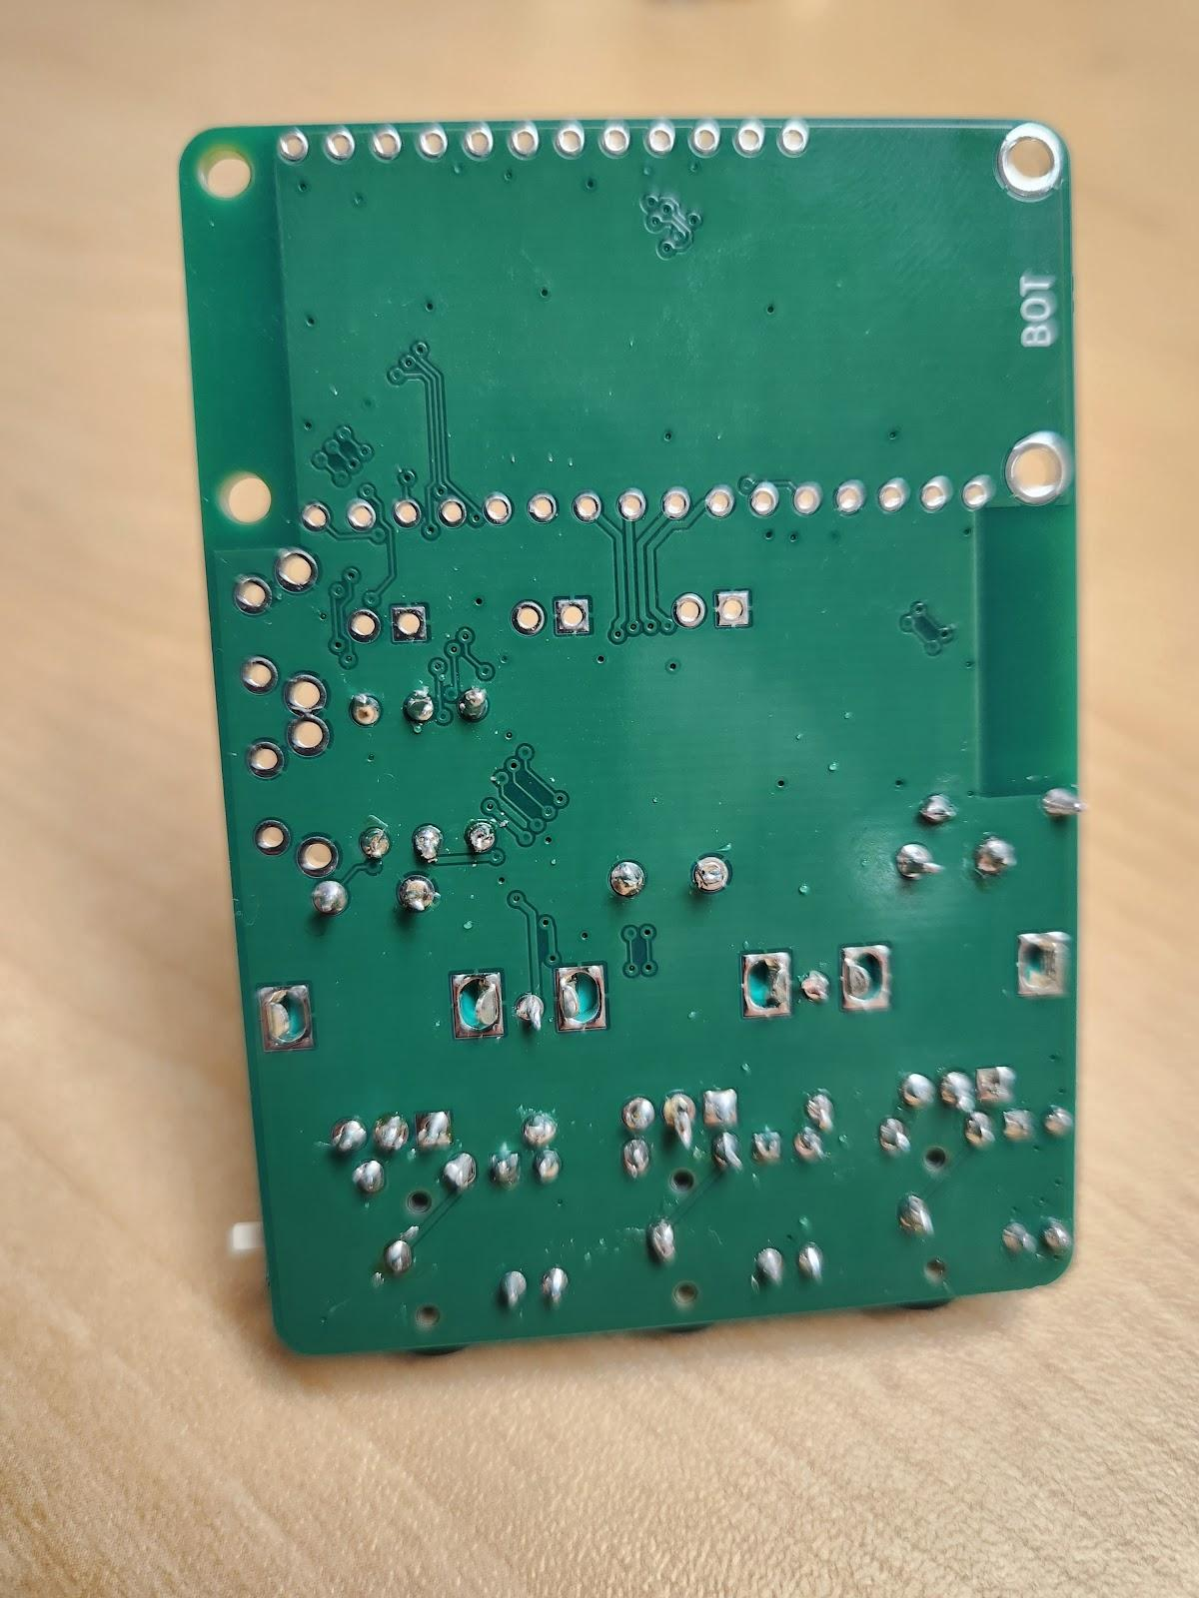

#### Step 8: Insert and Solder the LEDs

Measure and cut the **light tube (A10)** into three 8 mm pieces, if not already done.

Thread the leads of the **LED (A11)** through the light tube. 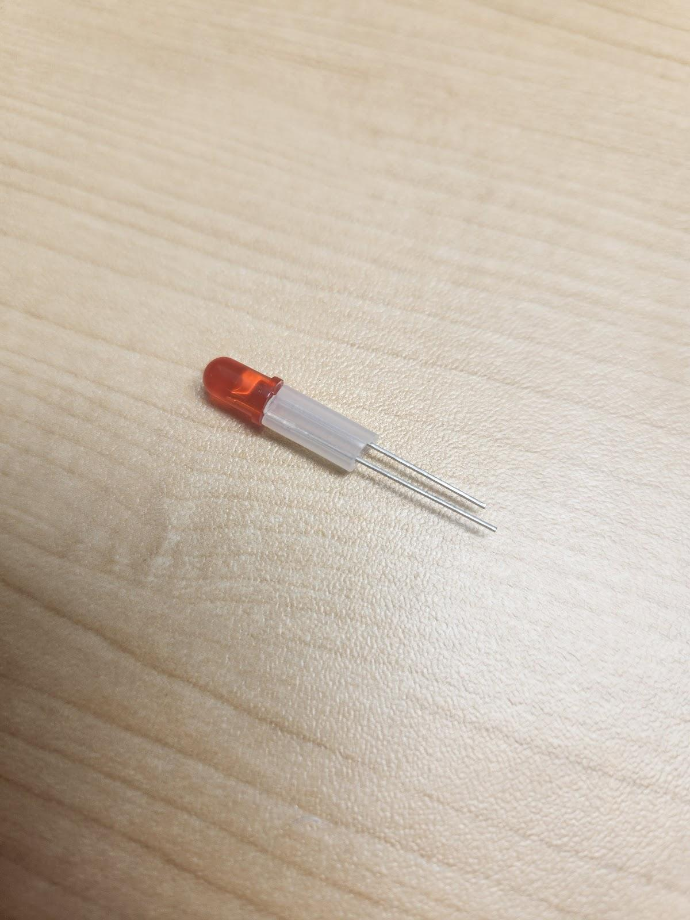

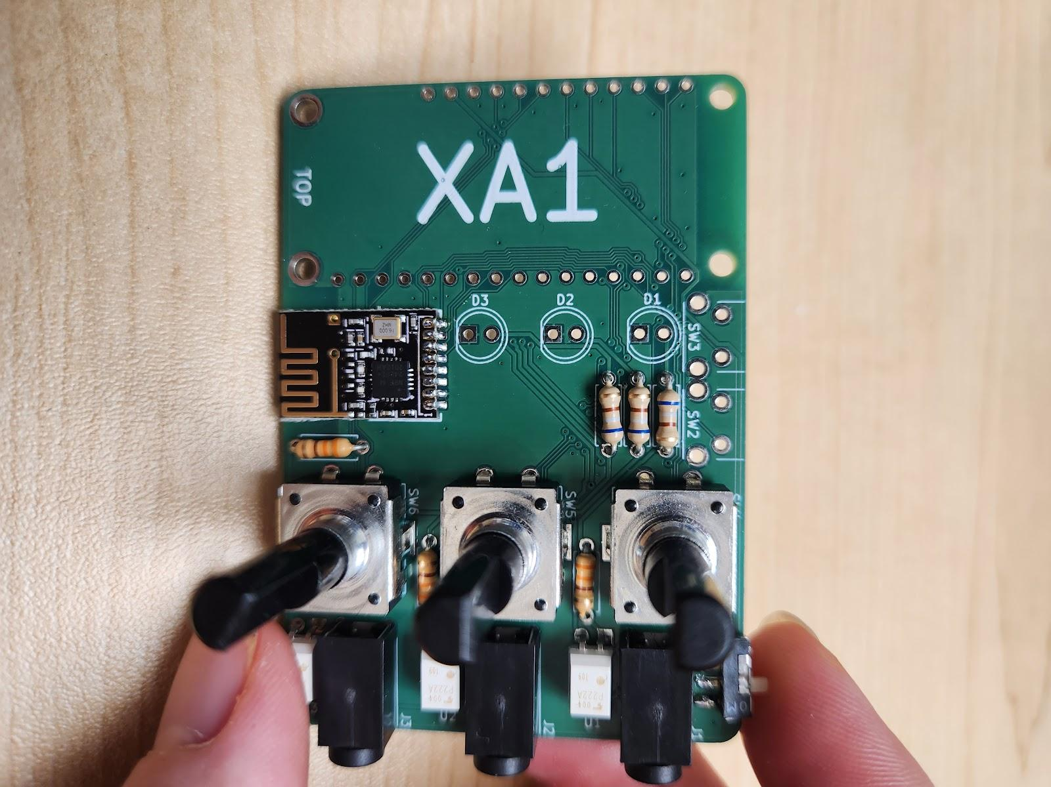

On the PCB, locate the circles labeled ‘D1’, ‘D2’, and ‘D3’. Within each circle, there is a **square pad** and a circular pad. Thread the leads of the LED through these pads, with **the shorter lead in the square pad**. The LED also has a flat edge that should line up with the flat edge on the outline on the PCB. Repeat for all three LEDs.

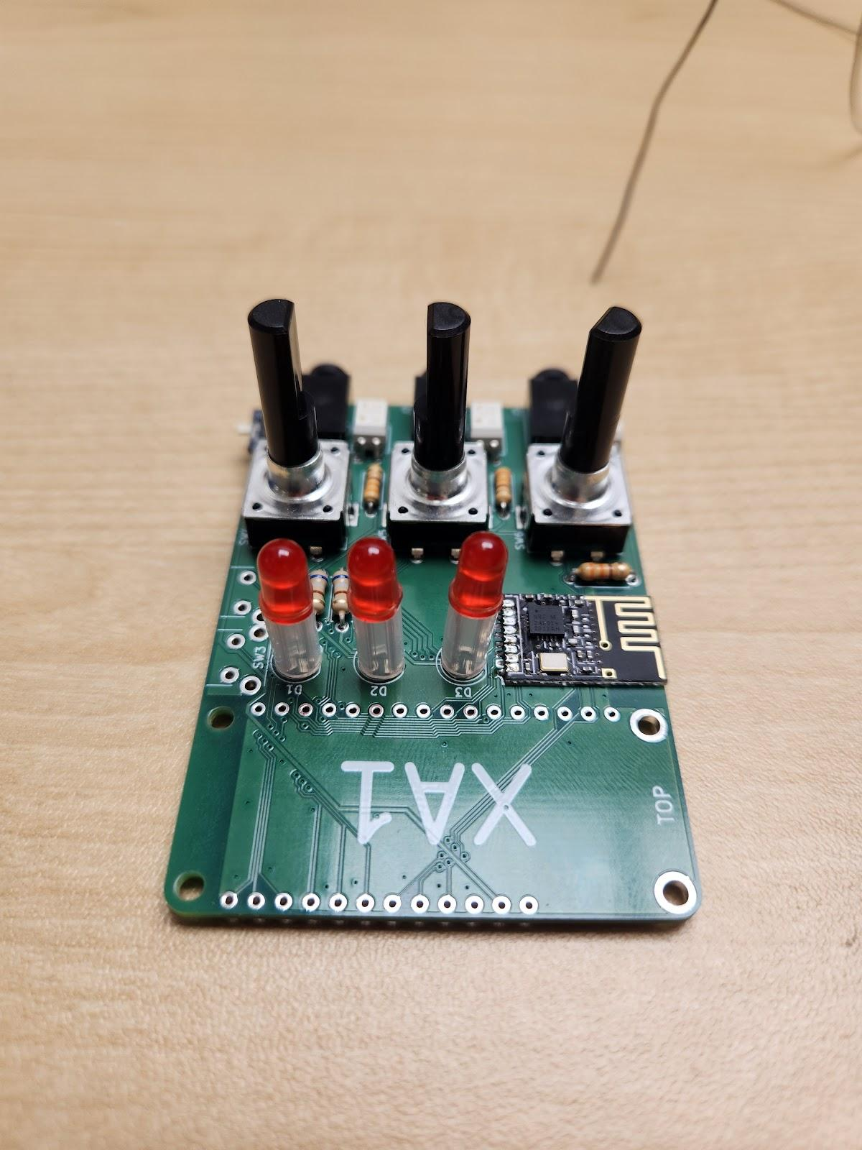

Flip the board over and solder the leads of the LEDs in place, then trim the leads flush with the PCB.

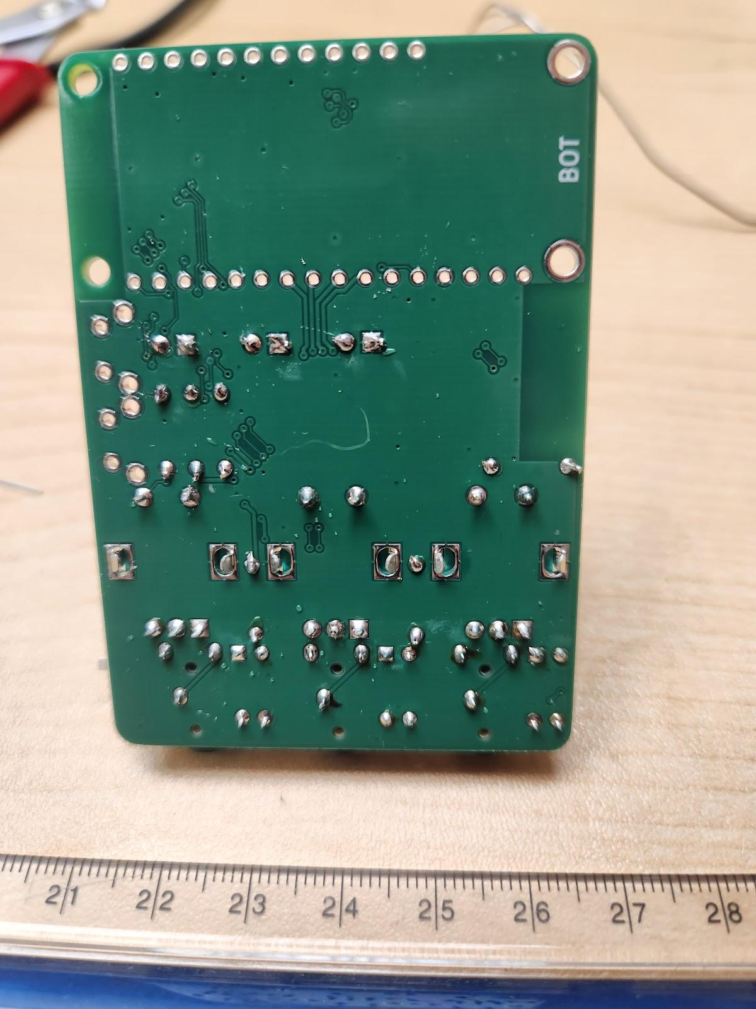

#### Step 9: Insert and Solder the Push Buttons

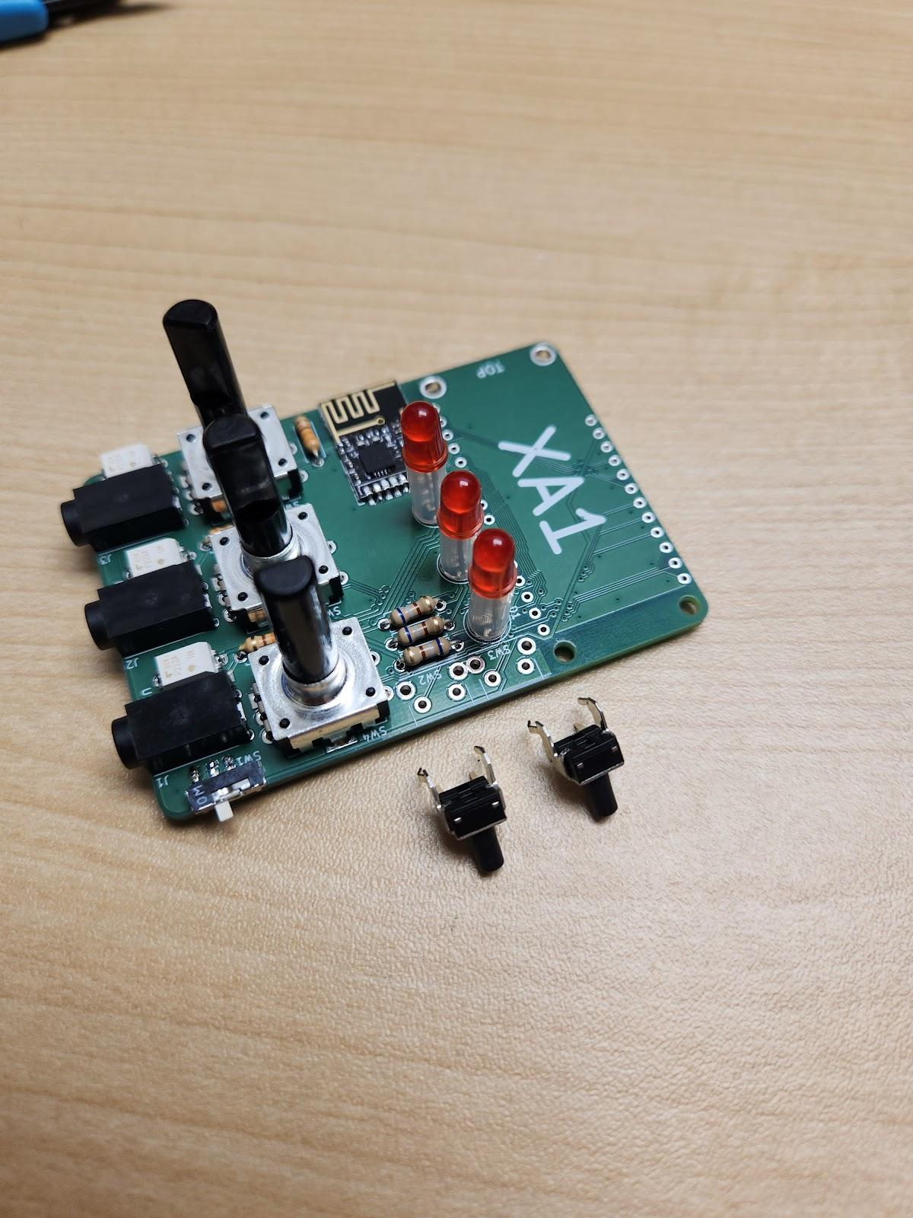Line up the **push buttons (A12)** on the PCB as shown, and insert into positions SW2 and SW3. They will only fit one way and will ‘snap’ into place.

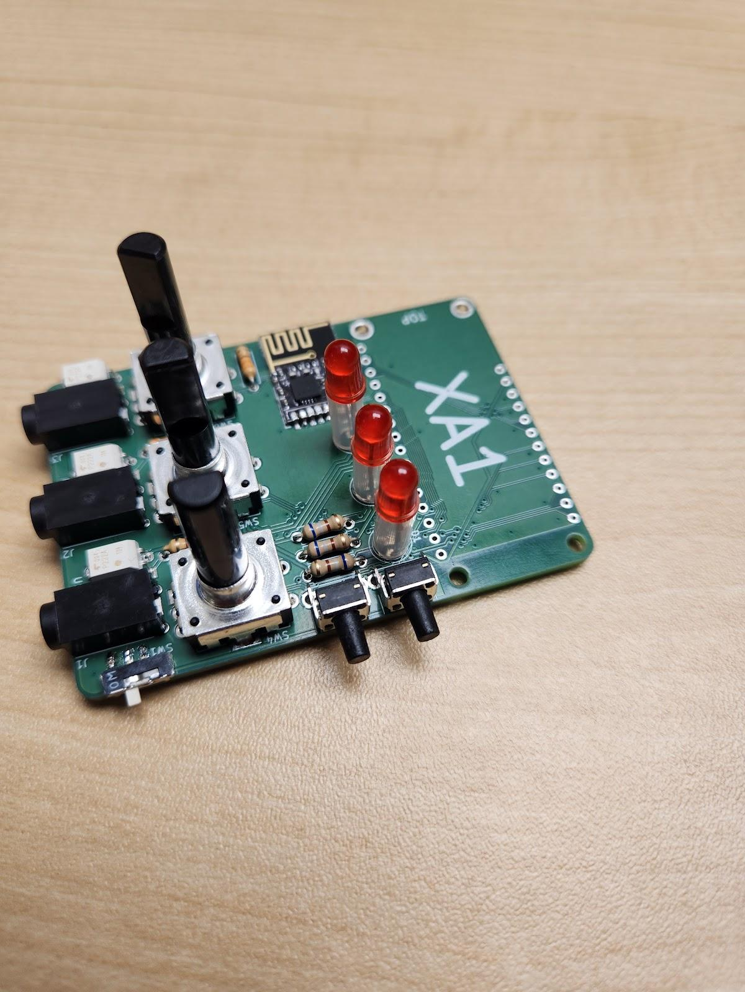

Flip the board over and solder the push buttons in place.

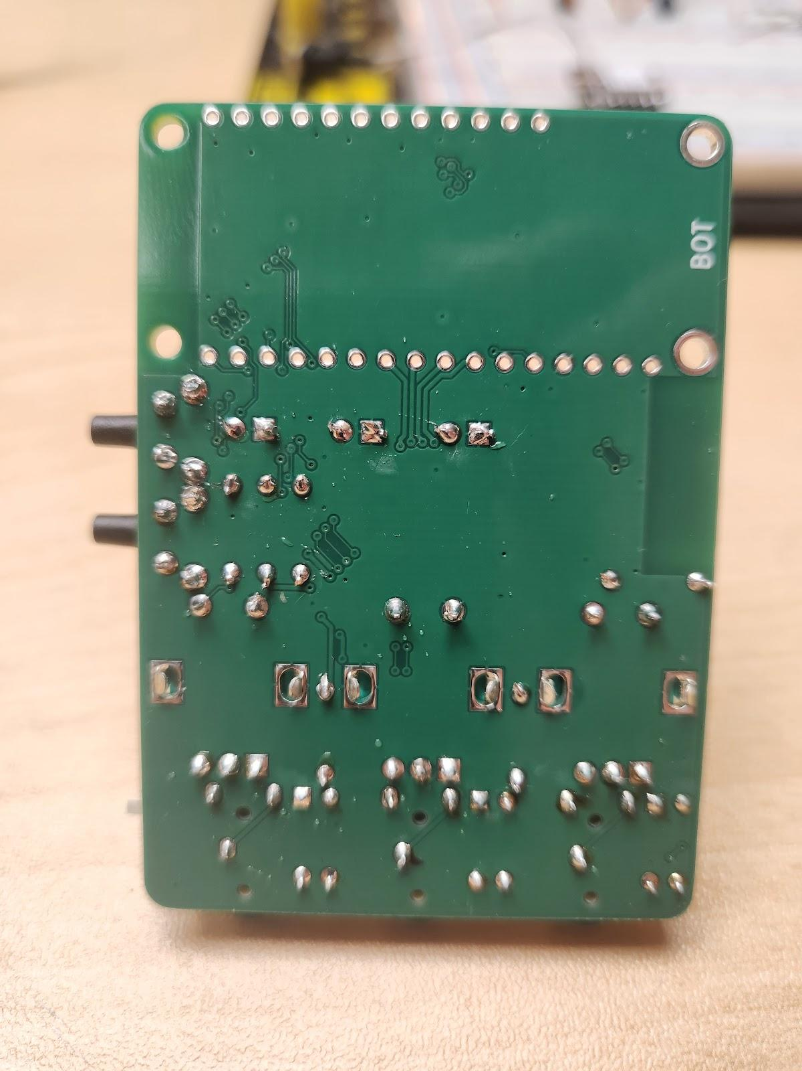

Note: It is ok if the two pins on the push buttons that are closest to each other form a bridge.

#### Step 10: Solder the Adafruit Board Headers

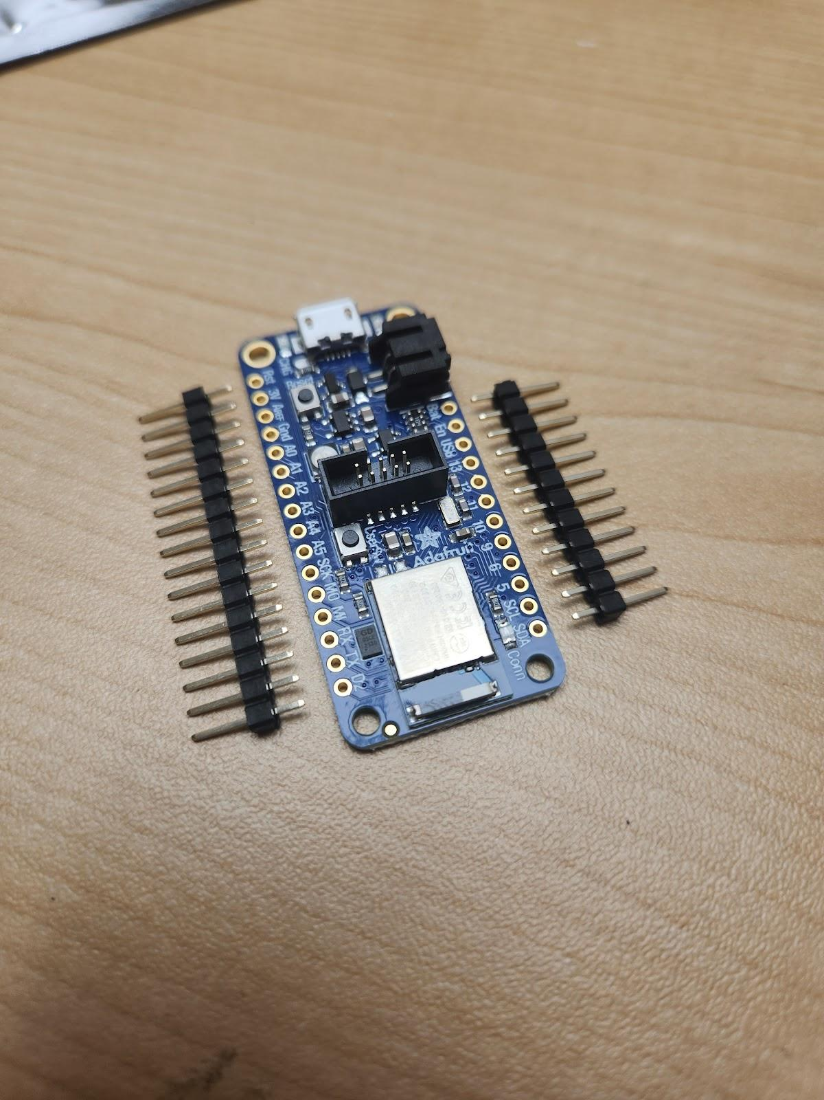To assemble the **Adafruit board (A02)**, place the **16- and 12-pin male headers (A13)** longside down into the breadboard. Place the Adafruit board onto the headers. Solder the headers in place.

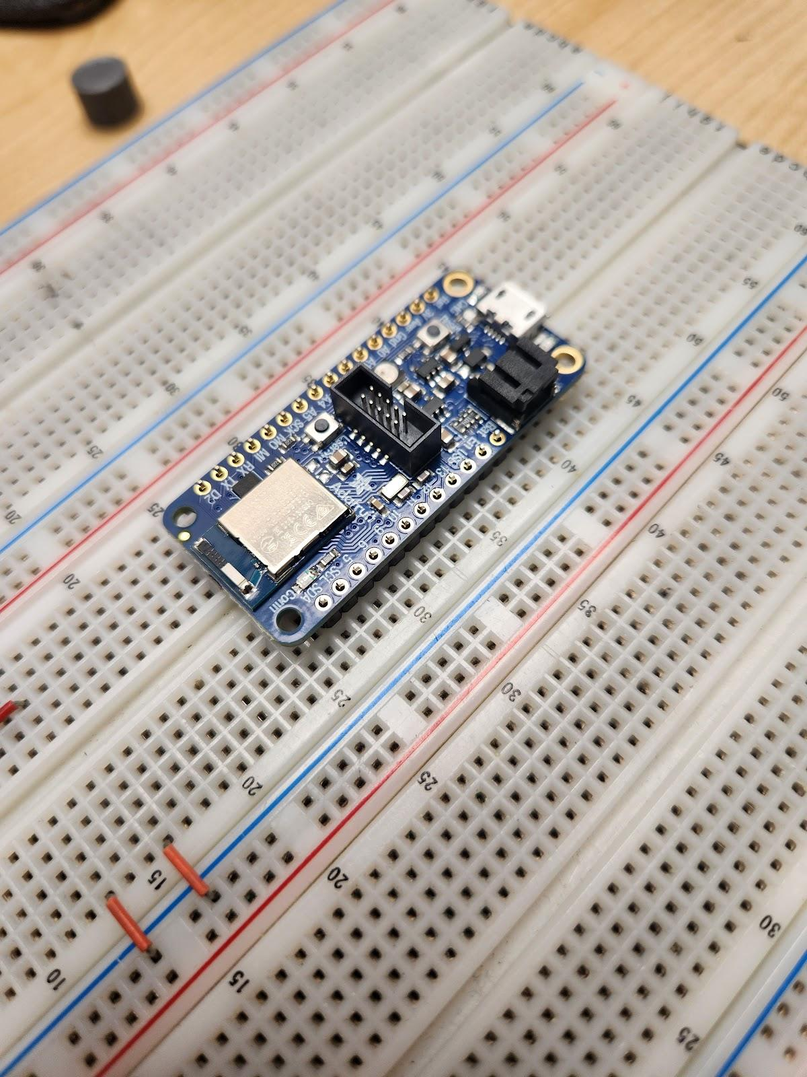

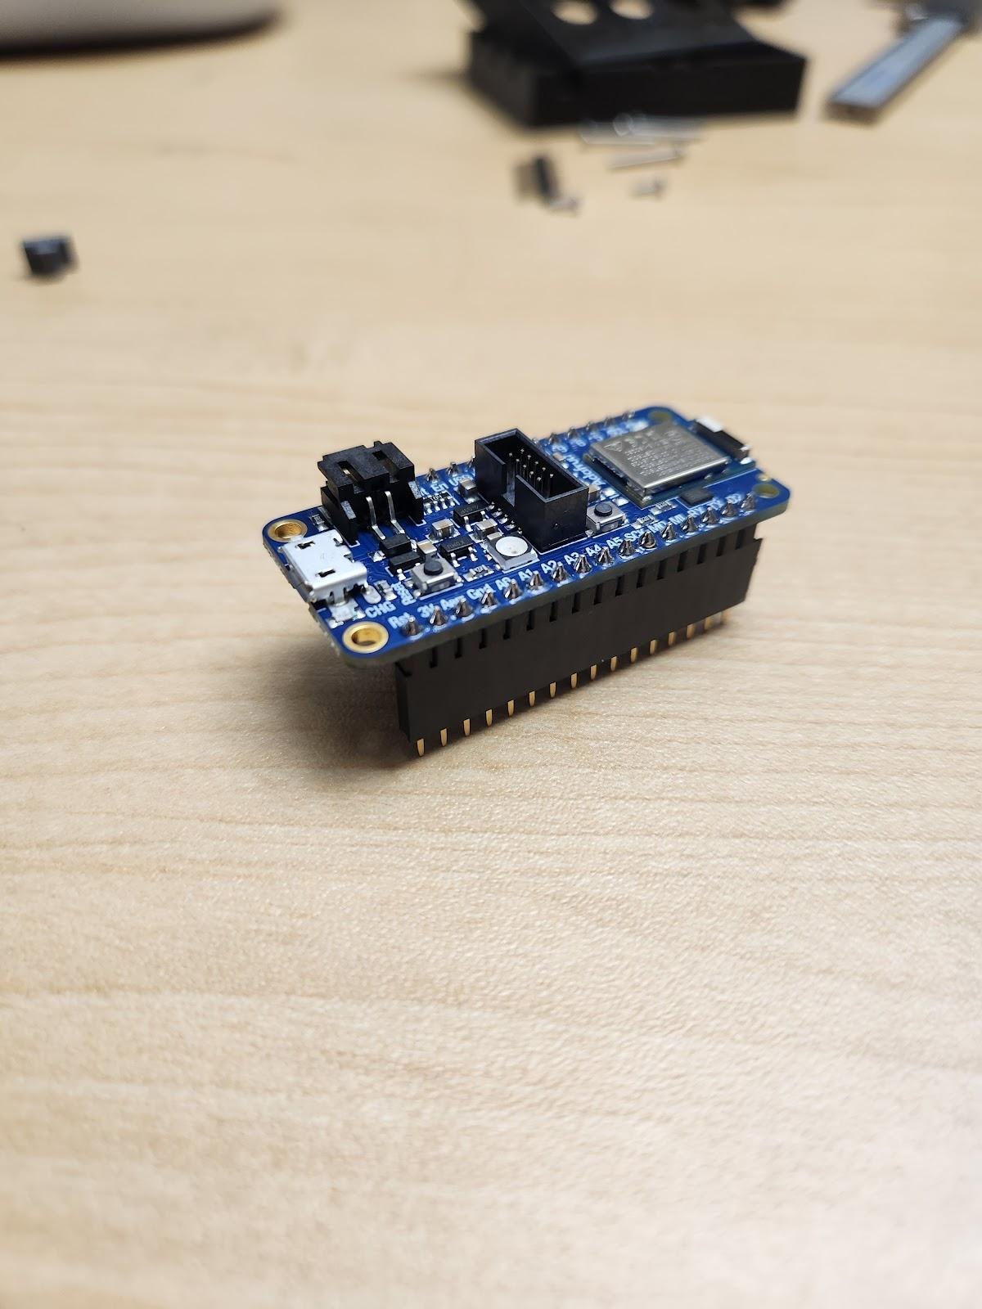

Next, remove the Adafruit board from the breadboard. Insert the pins of the male headers into the **16- and 12- pin female headers (A14)** as shown.

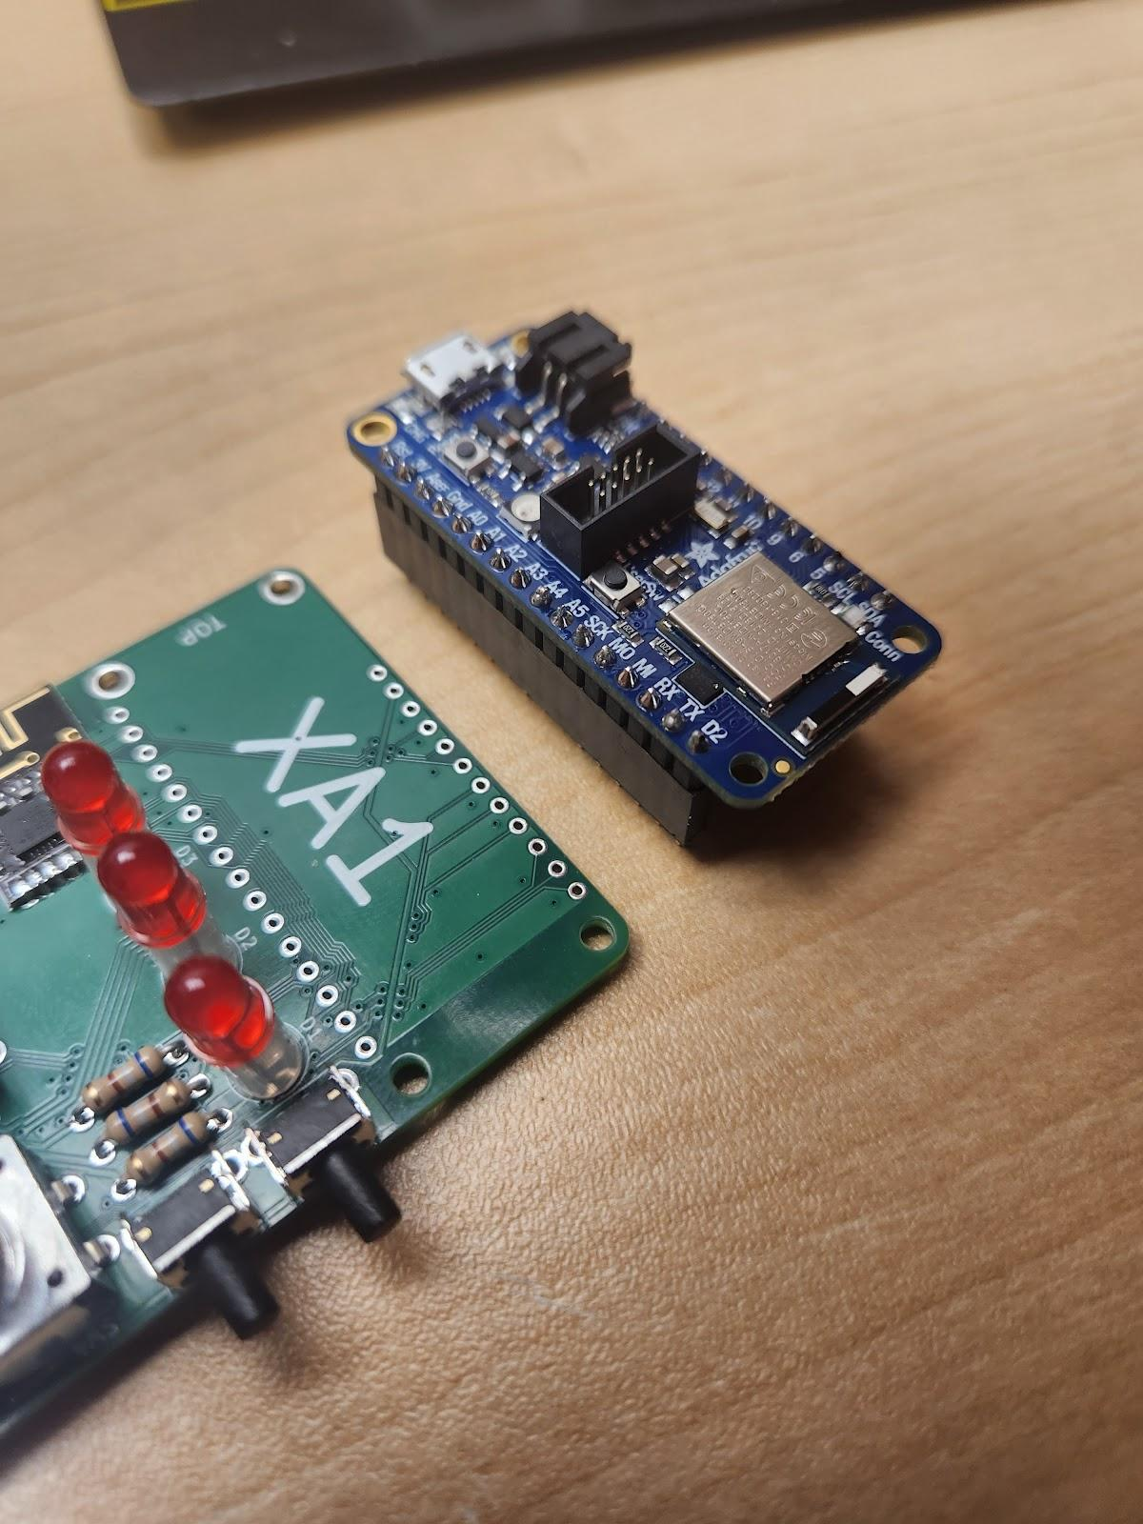

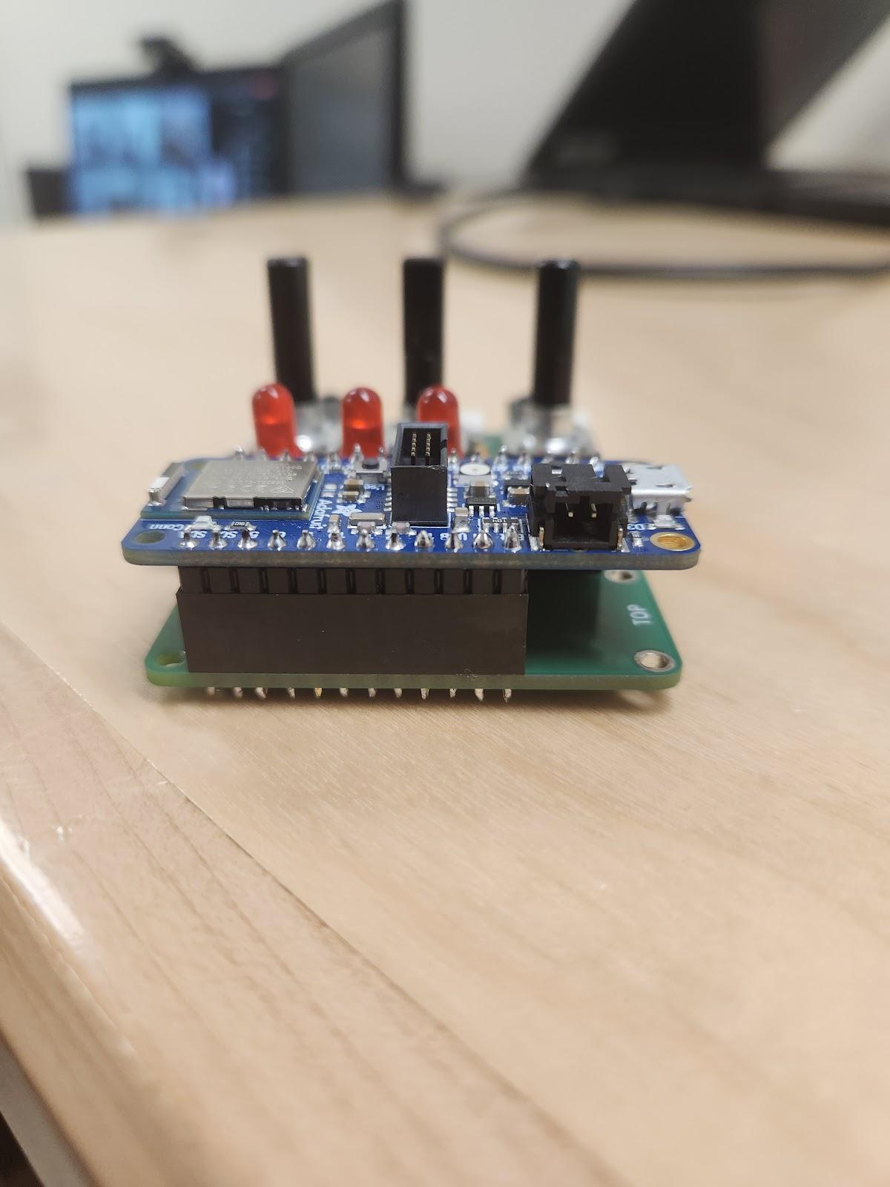Insert the female headers from the Adafruit board into the PCB at position ‘XA1’.

Flip the board over and solder the female headers in place.

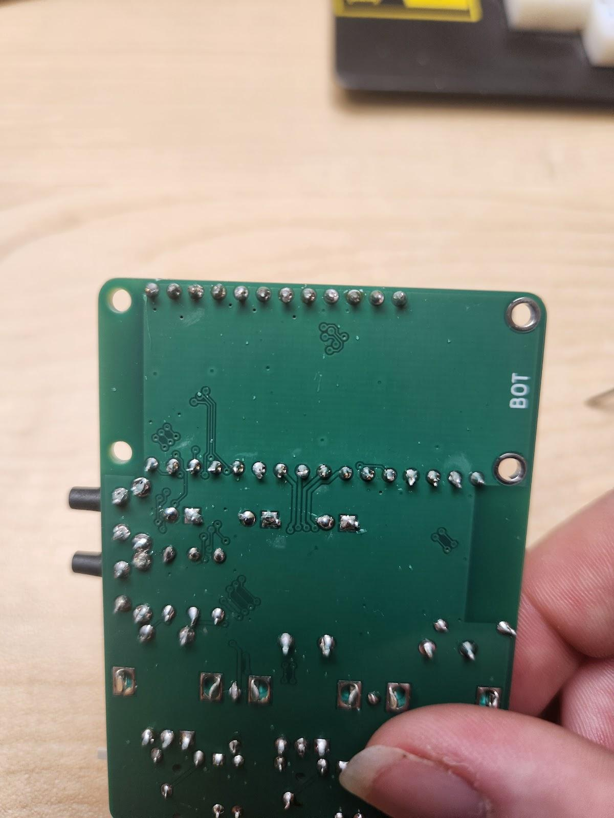

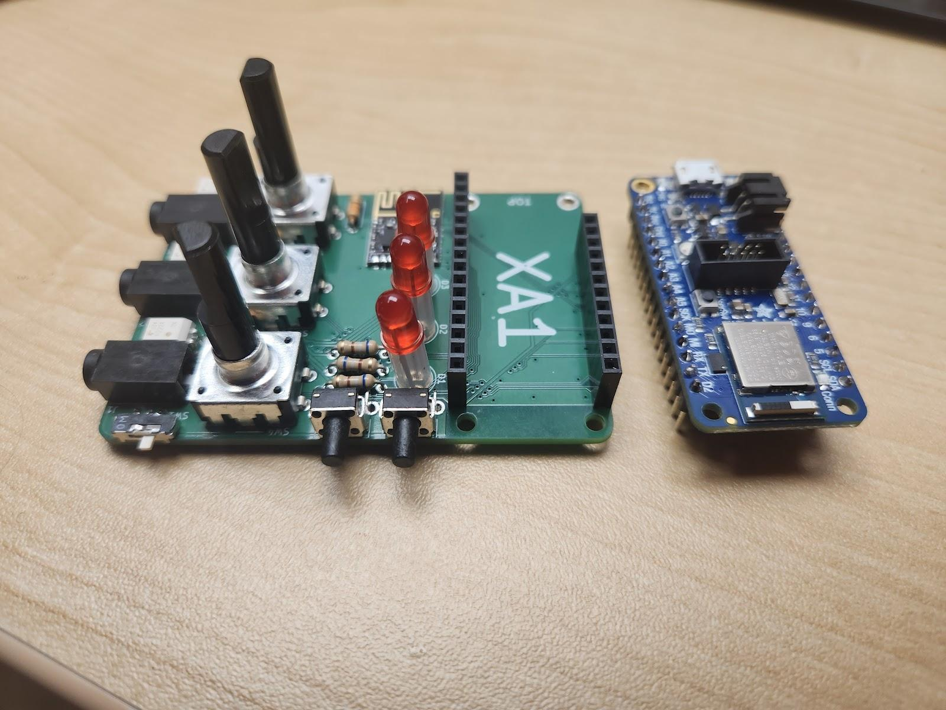You should now be able to separate the Adafruit board and the PCB.

#### Step 11: Final Assembly

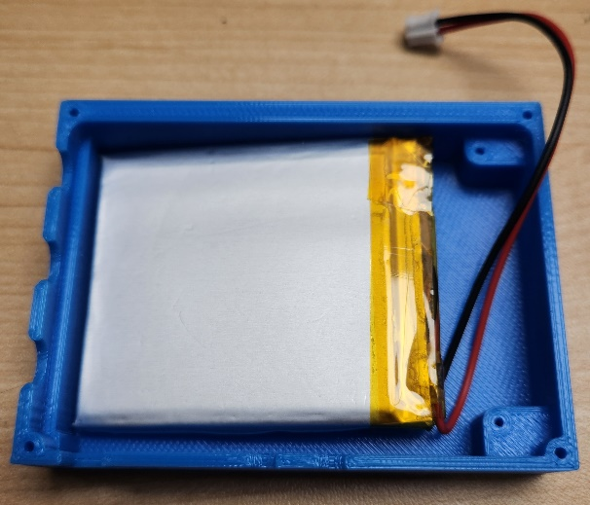Starting with the base of the **3D-printed case (A16.2),** place the **battery (A15)** in the case with the wires oriented towards the mounting holes.

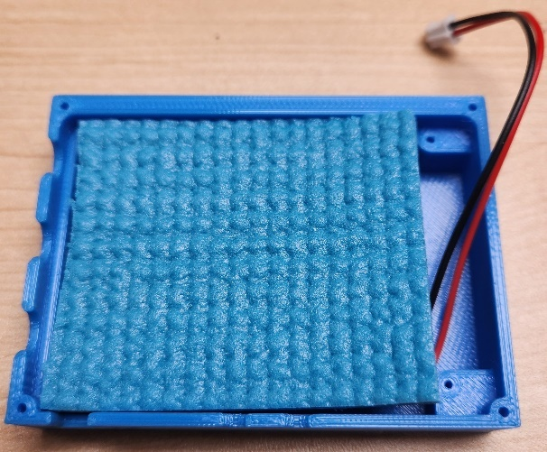Place the **insulating foam (A19)** overtop the battery.

Pace the PCB overtop the foam. Secure the PCB in place by screwing in the shorter, 5 mm, **screws (A20)** through the two mounting holes on the corners of the PCB.

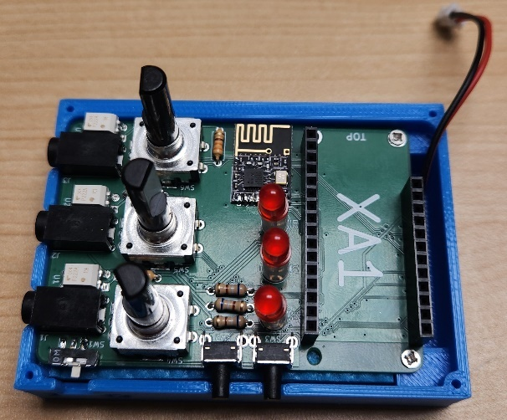

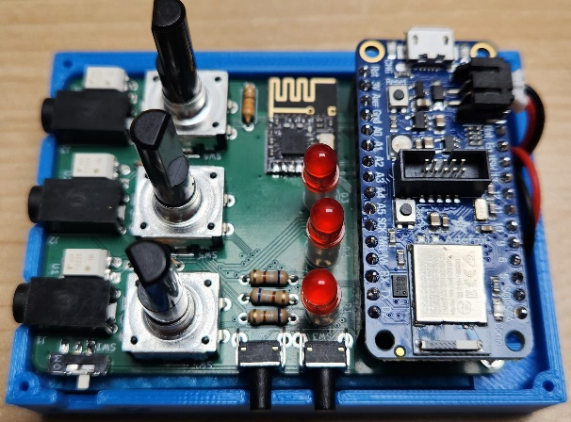Put the Adafruit board in place on the PCB, making sure the male headers line up with the female headers. Connect the battery to the Adafruit board using the black battery connector. Fold and tuck the wires into the base of the 3D-printed case.

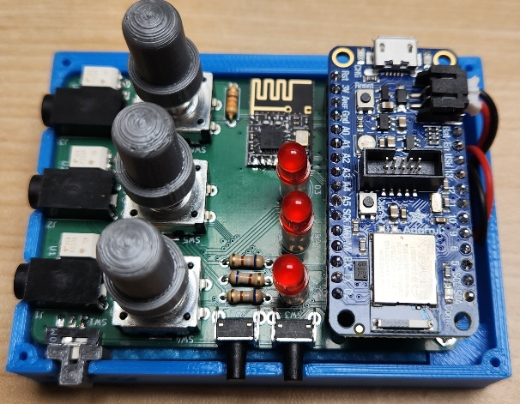Slide the **3D-printed switch cover (A17)** into place overtop the power switch. Do not force it. Place the **3D-printed dial covers (A18)** overtop of the dials; they will only fit one way.

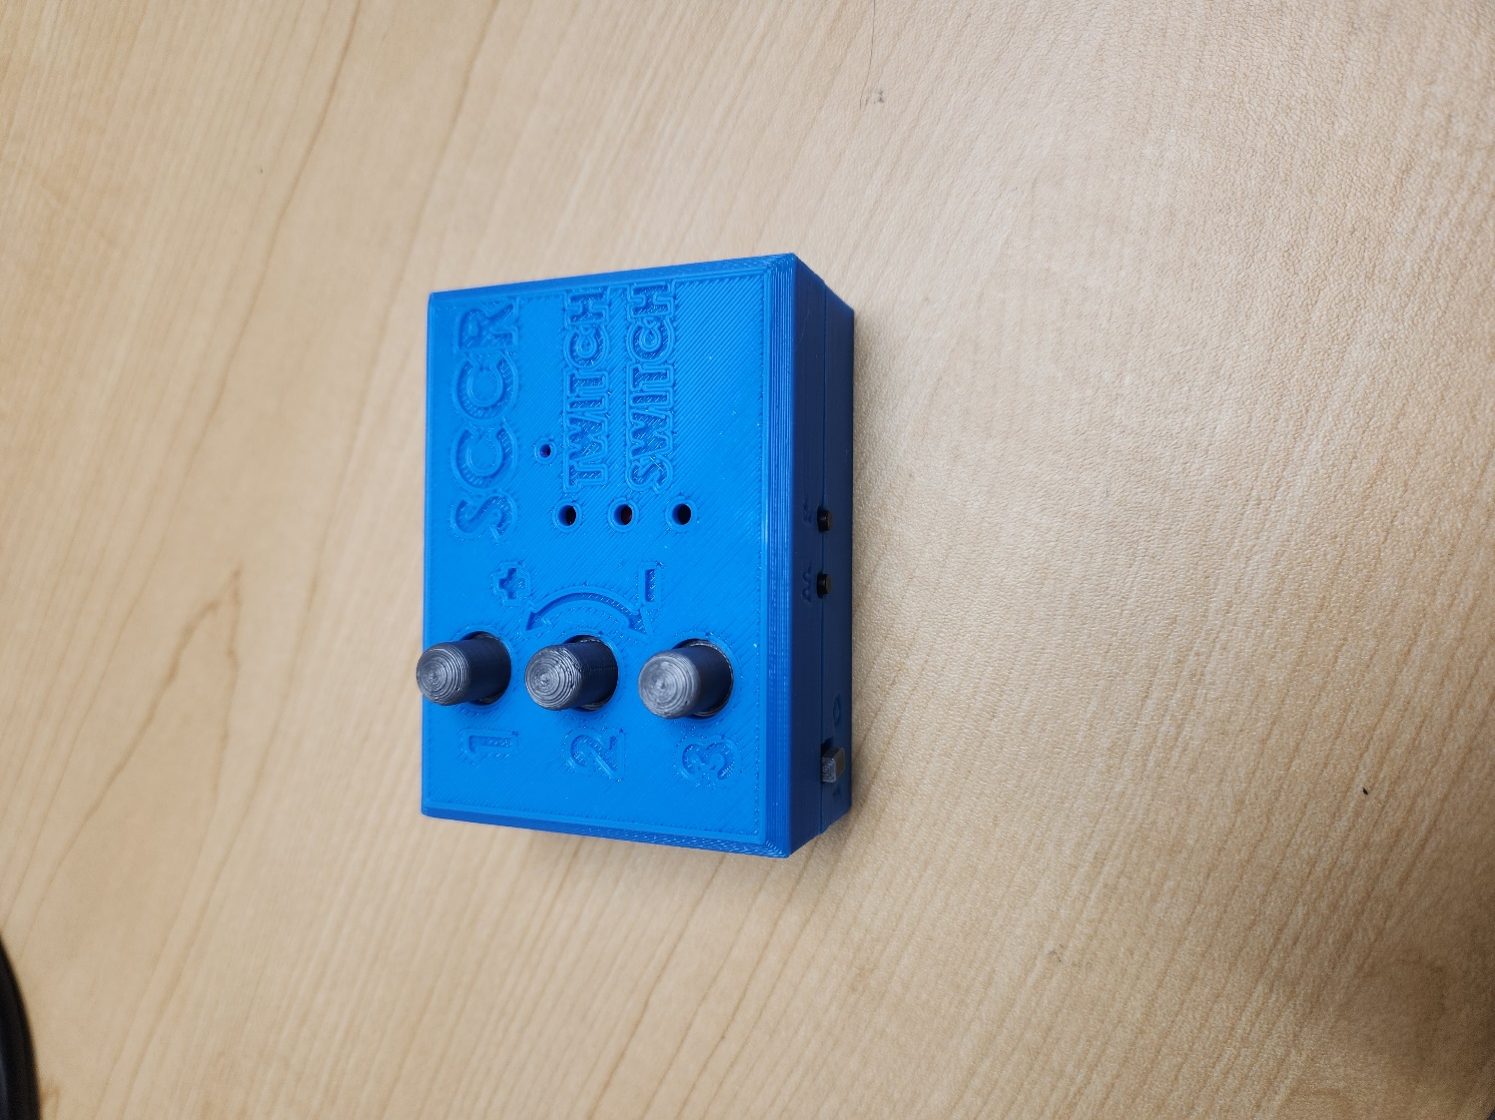

Before putting the lid of the 3D-printed case in place, it is recommended that you flash the device. Proceed to Part B: Flashing Firmware to Controller on page 25 for instructions on flashing the device.

To assemble the case, place the lid of the 3D-printed case overtop the PCB and flip the device over. Screw the case together using the **25 mm** **screws (A21)**.

Your Twitch Switch Controller is now assembled!

## Part B: Flashing Firmware to Controller

### Part B: Components

|  |  |  |
| --- | --- | --- |
| **B01** | Assembled Twitch Switch Controller | QTY 1 |
|  | | |

### Part B: Tools

|  |  |
| --- | --- |
| Computer with Arduino IDE to flash firmware  Arduino Tutorials - The Robotics Back-EndMonitor with solid fill | Micro-USB cable   |

### Part B: Controller Firmware Flashing Steps

#### Step 1: Setup Arduino IDE on Computer

1. Download Arduino IDE for your operating system at <https://www.arduino.cc/en/software>
2. Install the Arduino IDE.

#### Step 2: Setup Arduino IDE for Adafruit Feather nRF52840 Development Board

1. Open Arduino IDE.
2. Click on **File -> Preferences**.
3. Locate the text field that says **Additional Boards Manager URLs** beside it.
4. Copy and paste the following link into the field as a new line: <https://adafruit.github.io/arduino-board-index/package_adafruit_index.json>
5. Click on **OK.**
6. Restart the Arduino IDE.
7. Open the **Boards Manager** option from the **Tools-> Board-> Boards Manager...,**
8. **Search for “Adafruit nRF52” and select “Adafruit nRF52” by Adafruit.**
9. **Click Install to install the board.**

#### ****Step 3: Install Libraries****

1. Go to **Tools -> Manage Libraries…,** search for “rf24” and install the library “RF24” by TMRh20. Install version 1.4.8 or newer.
2. Go to **Tools -> Manage Libraries…,** search for “Adafruit Neopixel” and install the library “Adafruit DMA neopixel” by Adafruit. Install version 1.3.2 or newer. If you get a pop-up about library dependencies choose “INSTALL ALL”.
3. Go to **Tools -> Manage Libraries…,** search for “AceButton” and install the library “AceButton” by Bryan T. Park. Install version 1.10.1 or newer.

#### Step 4: Setup Local Code Directory

1. Download the Firmware_Files from the GitHub Repository:  
   <https://github.com/makersmakingchange/Twitch-Switch/raw/main/Build_Files/Firmware_Files/TwitchSwitchBaseFirmware.zip>
2. Extract / unzip the folder “TwitchSwitchBaseFirmware” to a known location.

#### Step 5: Connect the Base Unit to the PC

1. Using the USB-C cable, connect the controller to the PC. Make sure the **controller power switch is turned on.**
2. You should hear a chime from windows indicating that a device has been plugged in. If you **don’t** hear this sound, first check that your volume is turned up on your PC. Unplug then plug the device back in. If you still don’t hear a sound, you’ll need a different USB cable as [some cables are meant for charging only](https://www.dignited.com/50330/usb-data-cable-vs-usb-charging-cable/). **You need to use a cable that can transfer data.**

#### Step 6: Burn the Bootloader

There was a bug in the bootloader of the initial version of the hardware we received from the vendor. The latest version of the bootloader will fix this. This only needs to be done once.

You will know that the bootloader has been burned if, when you turn the controller on, the LED blinks purple for a couple of seconds. If the LED is red when you turn the controller on, the bootloader has not been burned.

1. Select Tools > Programmer > Select Bootloader > DFU for Bluefruit nRF52.
2. Select Tools > Burn Bootloader
3. If you get an error about the board not being in DFU mode, you’ll need to open the case and double press on the ‘reset’ button. The LED on the board should go GREEN. Now select ‘Burn Bootloader’ again. If you still get an error, double check that you have the correct COM port selected.
4. You’ll know the bootloader has been successfully programmed when you see the following:

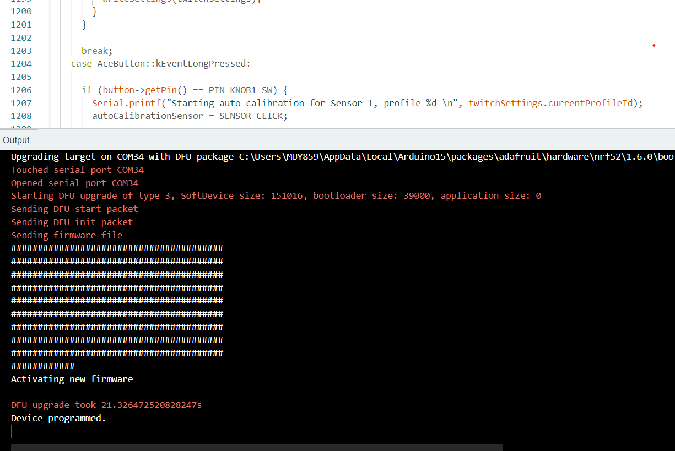

#### Step 7: Upload the Code to the microcontroller

1. Open TwitchSwitchBaseFirmware.ino with Arduino IDE.
2. **Select Adafruit Feather nRF52840 Express from Tools -> Board -> Adafruit nRF52 Boards**
3. Connect the Twitch Switch Controller using the USB cable to the computer.
4. Select the correct port from **Tools -> Port** menu.
5. Verify and upload the code.

## Part C: Twitch Switch Sensors Assembly

### Part C: Components

|  |  |  |  |  |  |  |  |  |
| --- | --- | --- | --- | --- | --- | --- | --- | --- |
| **C01** | PCB - Twitch Switch Sensor | QTY 3 | **C02** | Radio | QTY 3 | **C03** | Power switch | QTY 3 |
|  | | |  | | |  | | |
| **C04** | Battery Connector | QTY 3 | **C05** | 3.7V 110mAh lithium-ion polymer battery | QTY 3 | **C06** | 3D Printed Enclosure Bottom | QTY 3 |
|  | | |  | | |  | | |
| **C07** | 3D Printed Enclosure Top – Sensor 1 | QTY 1 | **C08** | 3D Printed Enclosure Top – Sensor 2 | QTY 1 | **C09** | 3D Printed Enclosure Top – Sensor 3 | QTY 1 |
|  | | |  | | |  | | |

### Part C: Tools

|  |  |  |
| --- | --- | --- |
| Fine-tipped soldering iron   |  |  |

### Part C: Personal Protective Equipment (PPE)

* Protective eyewear

### Part C: Twitch Switch Controller Assembly Steps

#### Step 1: Position and Solder the Radio

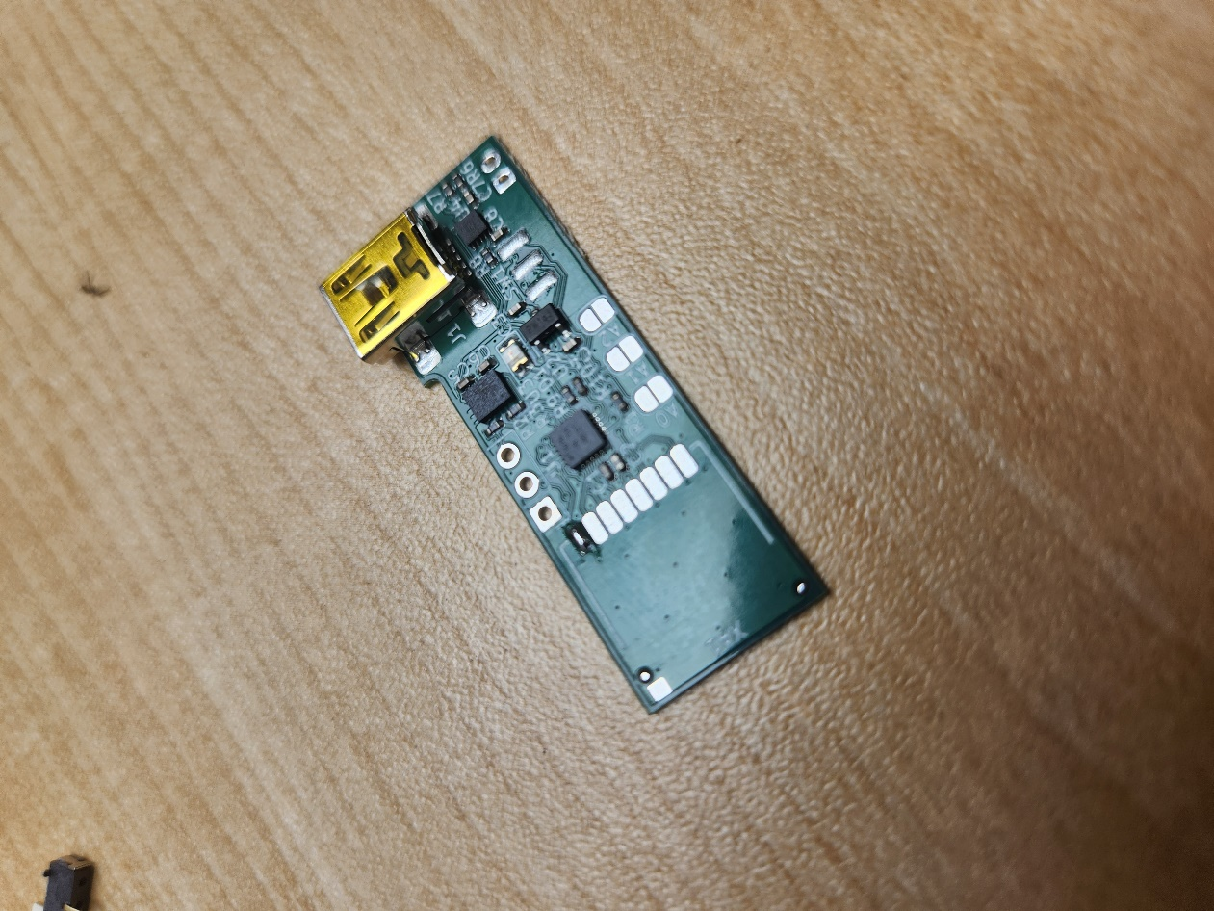Begin with the **Twitch Switch Sensor PCB (C01)** and the **radio (C02)**. Locate the blank square on the PCB marked with ‘XA1’. This is where the radio will be placed. Apply a dab of solder onto one of the pads.

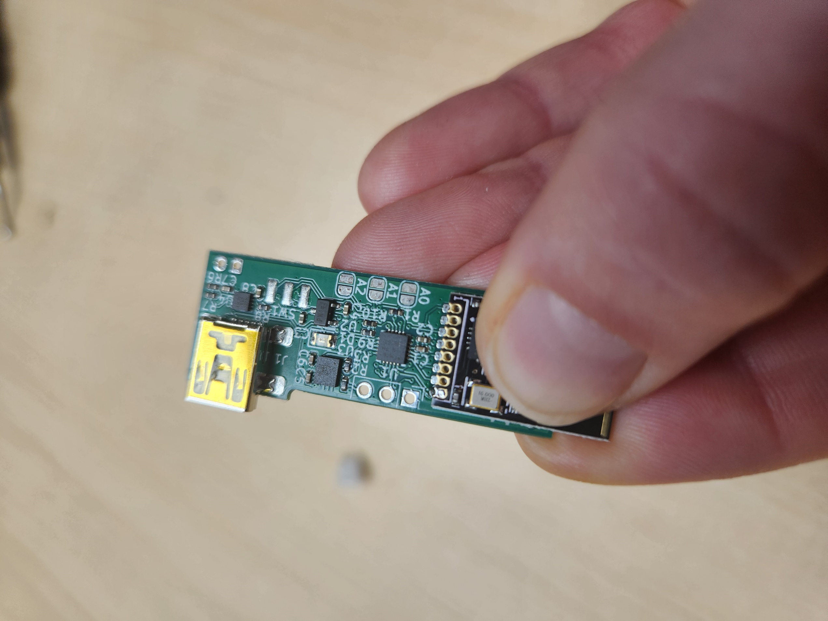Pinch the radioand the PCB together so that the pads of the radio and PCB partially overlap. Heat the dab of applied solder to secure the radio in place. Ensure radio is still straight and flush with the PCB before continuing.

Apply a dab of solder to the next pad of the radio. While still hot, draw the soldering down to the pad of the PCB so that the two connect. Repeat for each pad.

Ensure the solder between each pad **doesn’t bridge**.

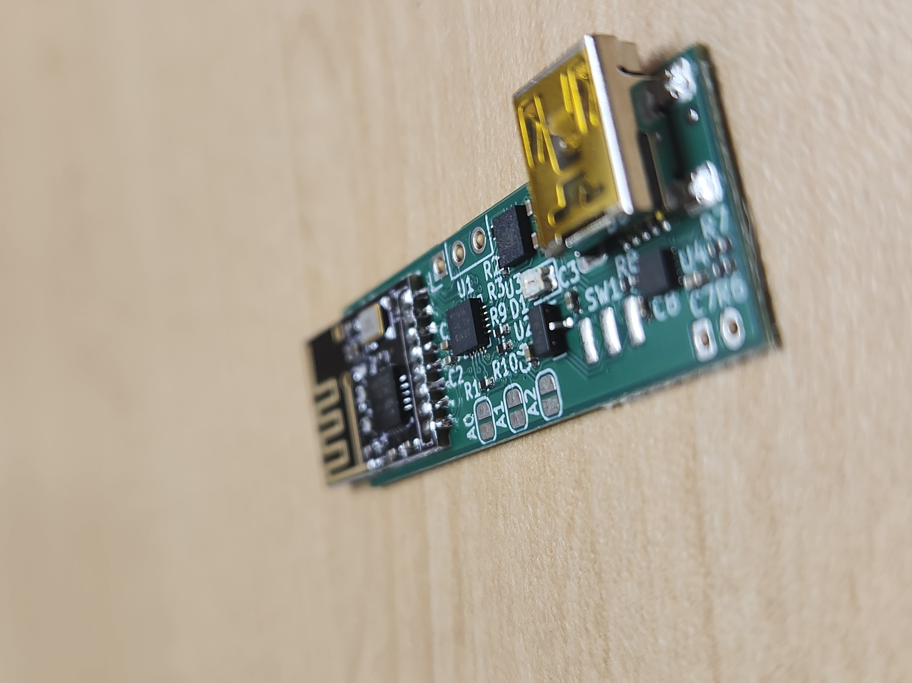**Repeat for all three sensors.**

#### A close-up of a circuit board Description automatically generatedStep 2: Solder the Power Switch

Next, prepare the **power switch (C03)**. Locate the three pads on the PCB next to ‘SW1’ and apply a small dab of solder onto one of the three pads of the PCB as shown. **Tin** the bottoms of the leads of the power switch.

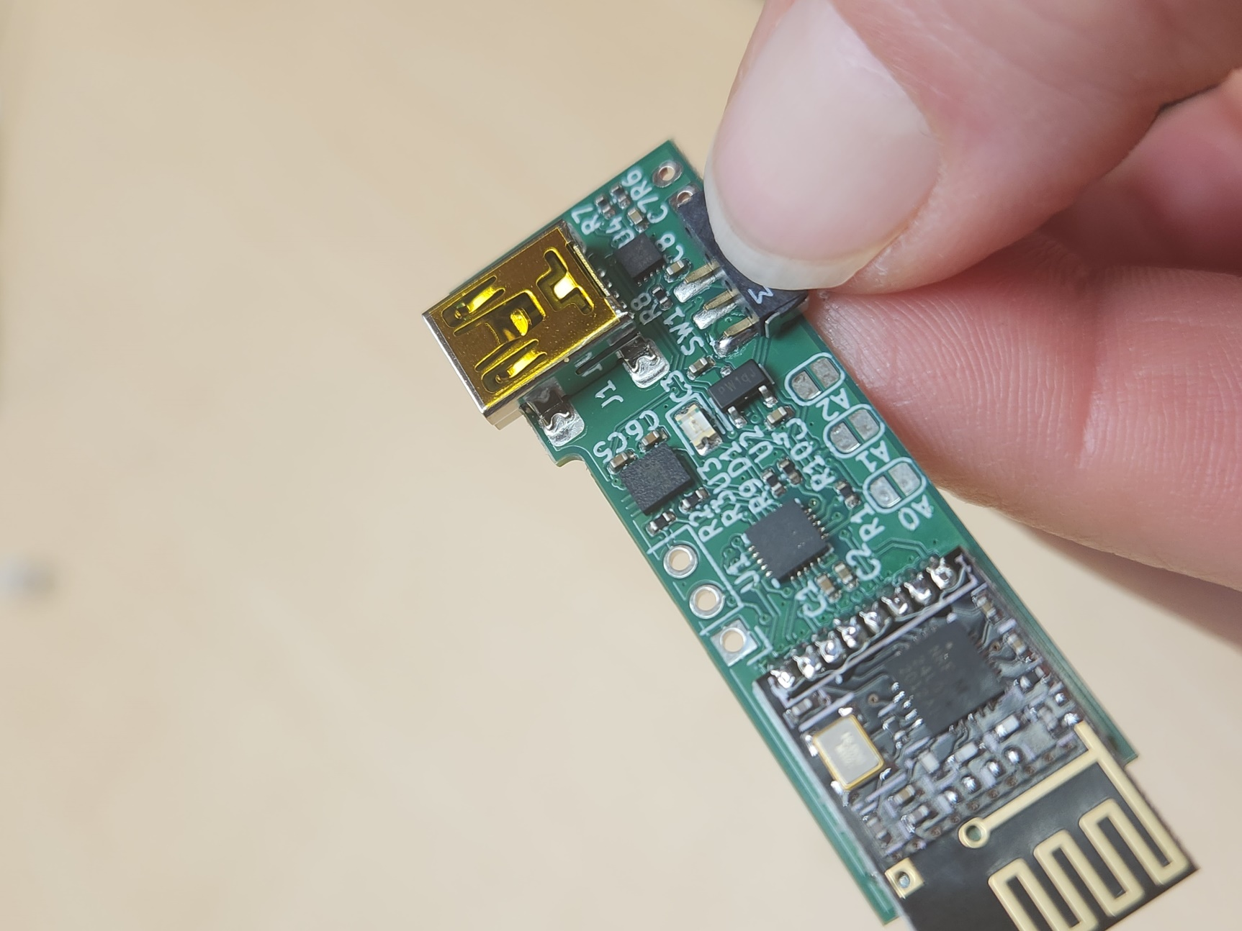

Flip the power switch over and pinch the PCB and the power switch together. The “feet” of the power switch will be flush with the edge of the PCB. Solder the first lead to the PCB. This will secure the power switch in place.

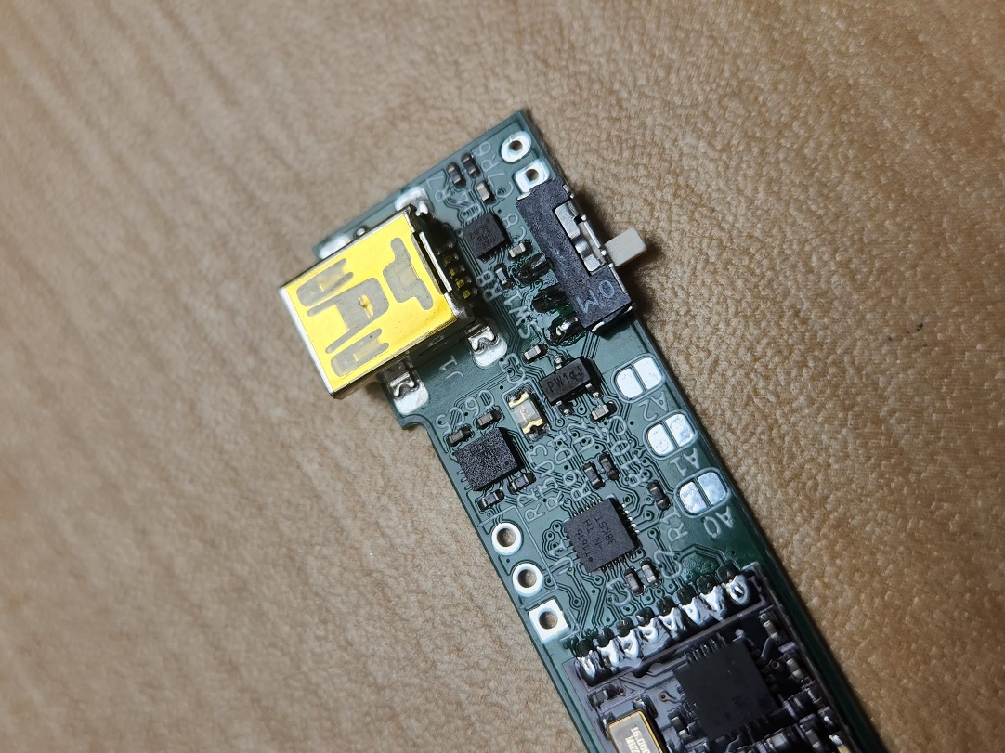Ensure the switch is still flush with the PCB before soldering the other two leads.

Ensure soldering on each pad **doesn’t bridge**.

**Repeat for all three sensors.**

#### A small green circuit board with a white connector Description automatically generatedStep 3: Attach and solder the Battery Connector

Next, flip the PCB over. The **battery connector (C04)** is mounted on the bottom of the PCB. Line up the battery connector with the outline on the PCB labelled ‘J3’ as shown.

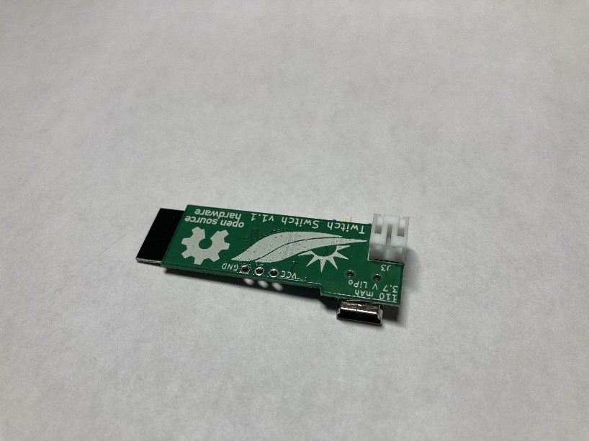

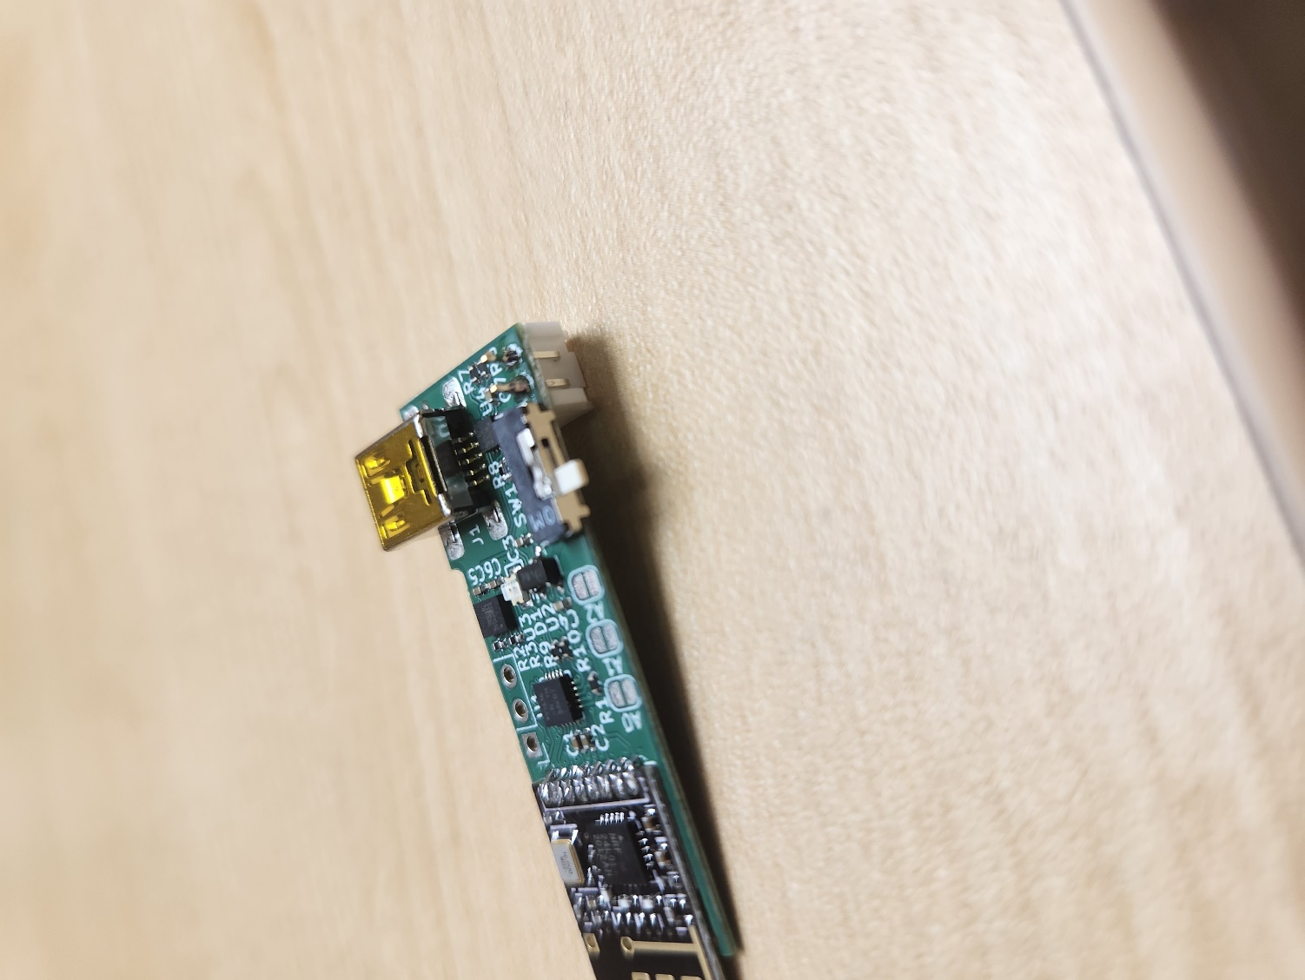

Flip the PCB over and solder the battery connector in place.

**Repeat for all three sensors.**

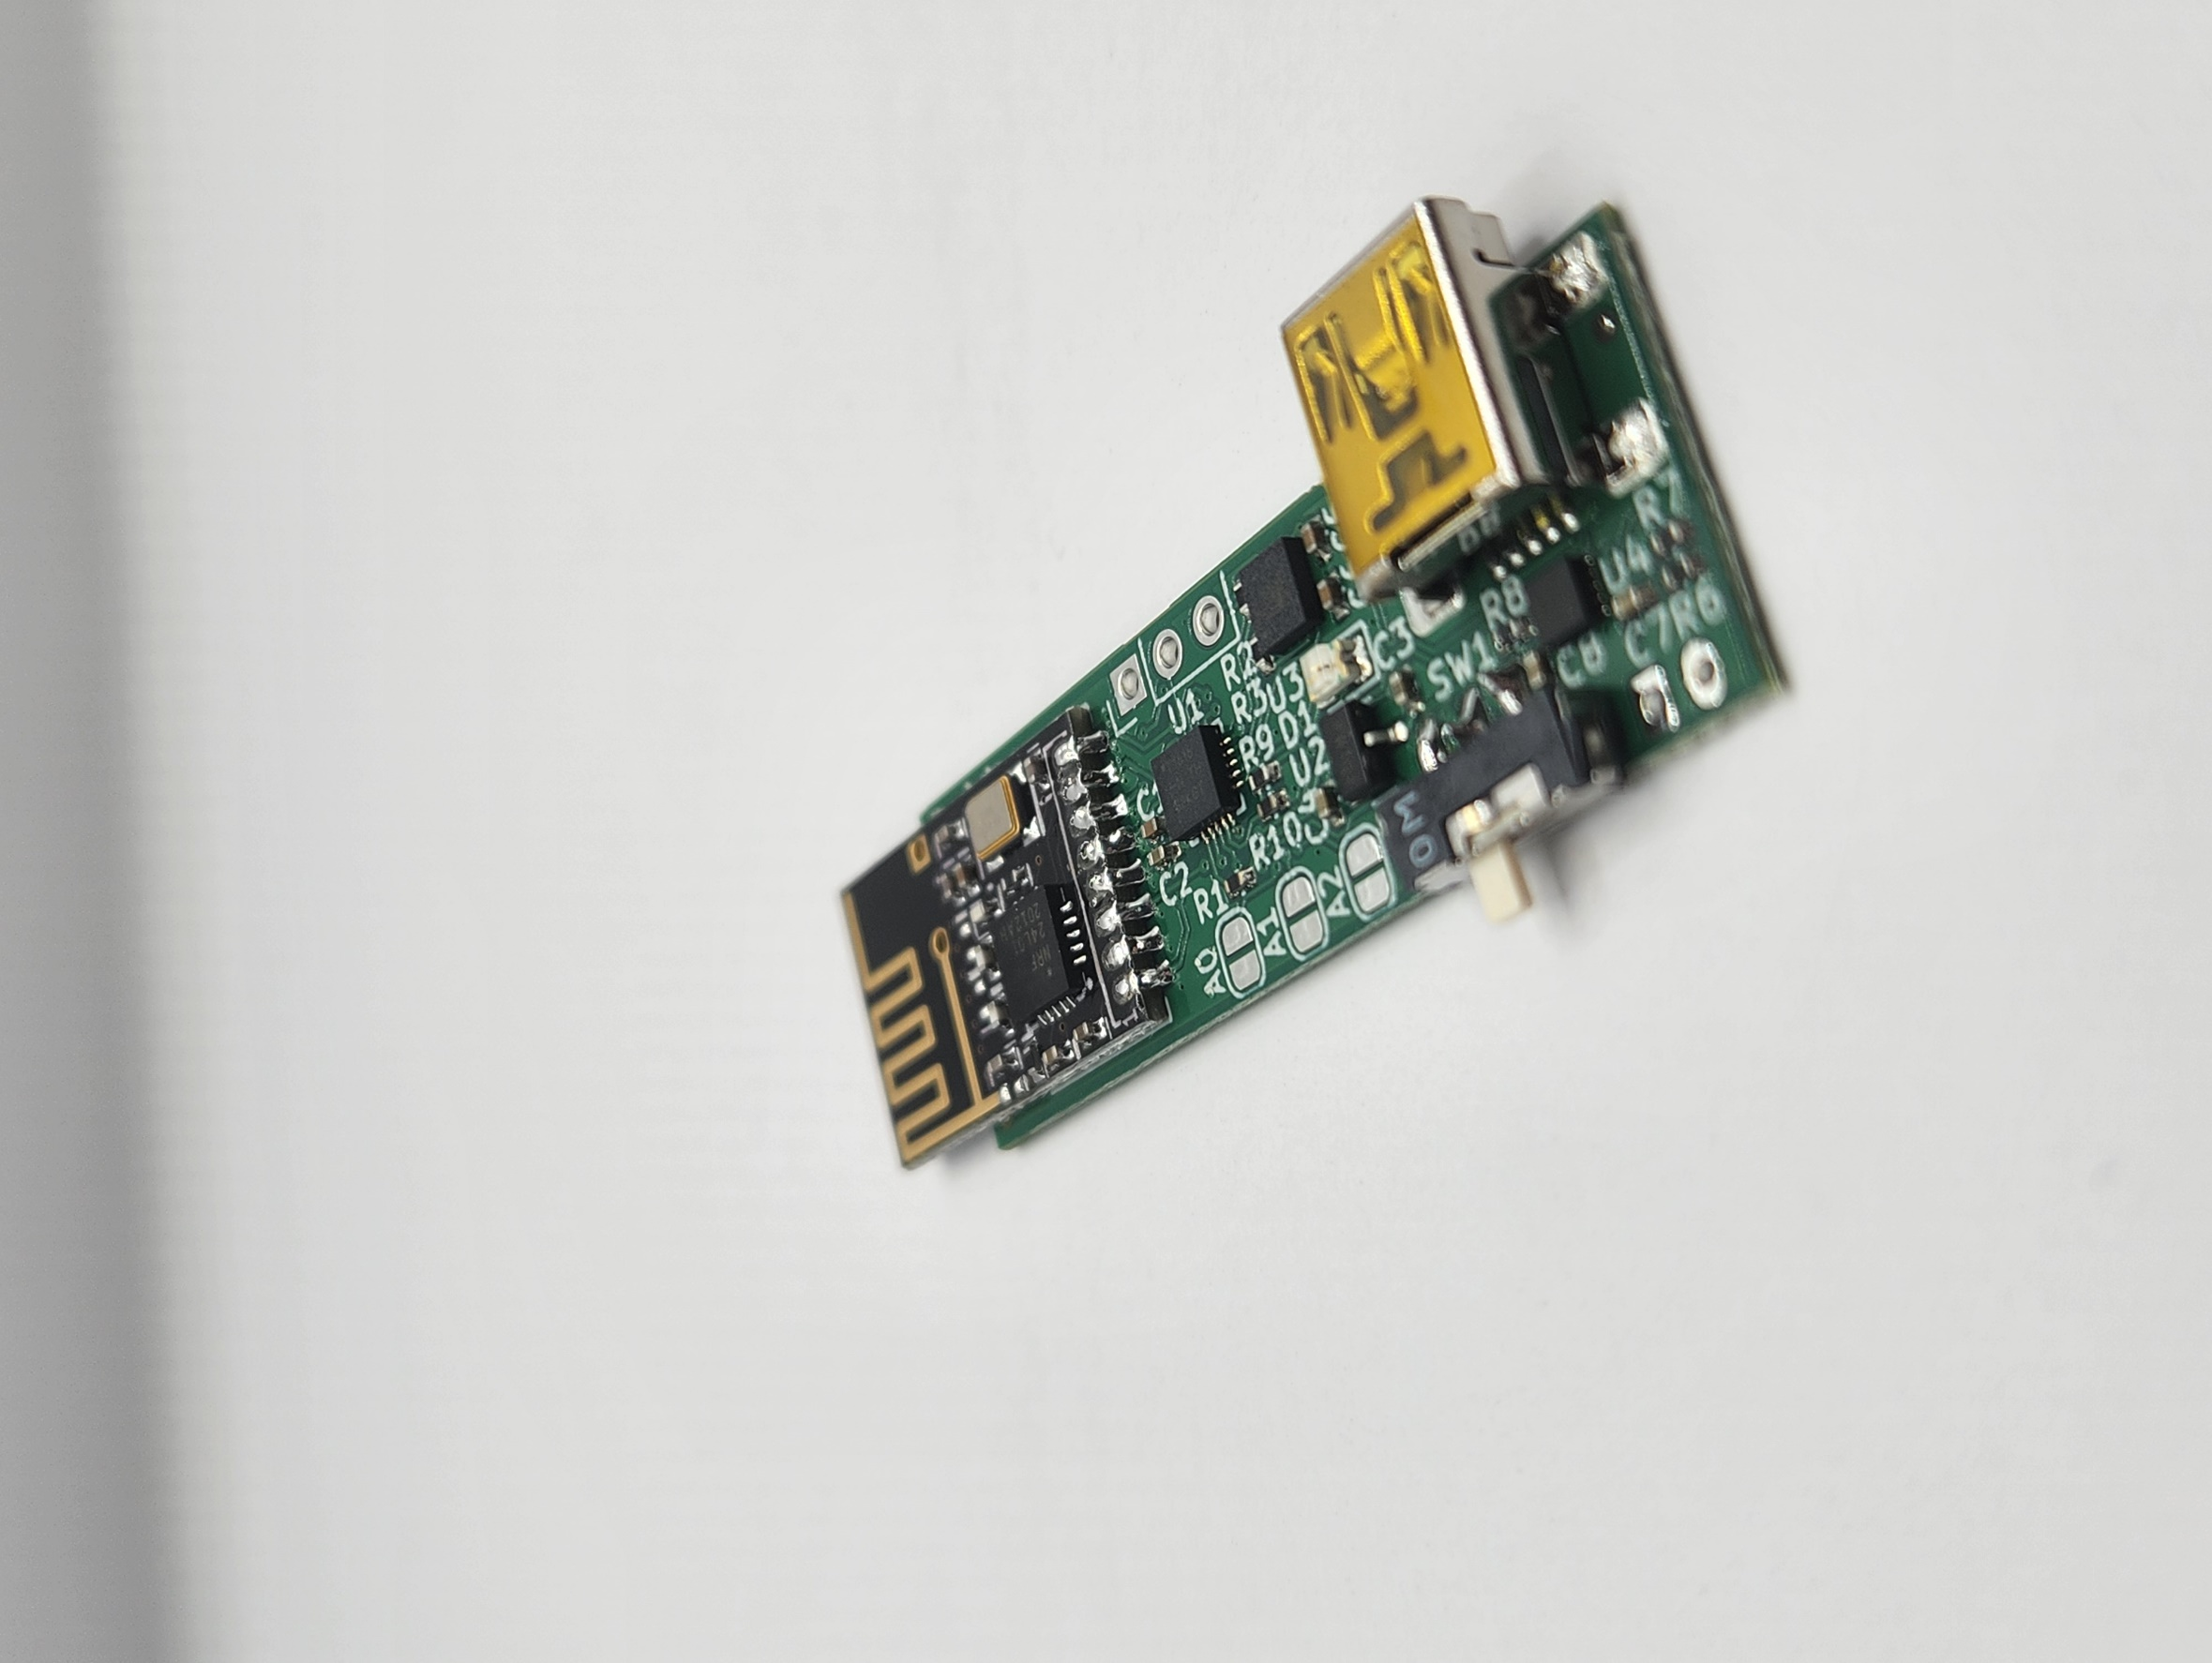

#### Step 4: Determining Sensor Number

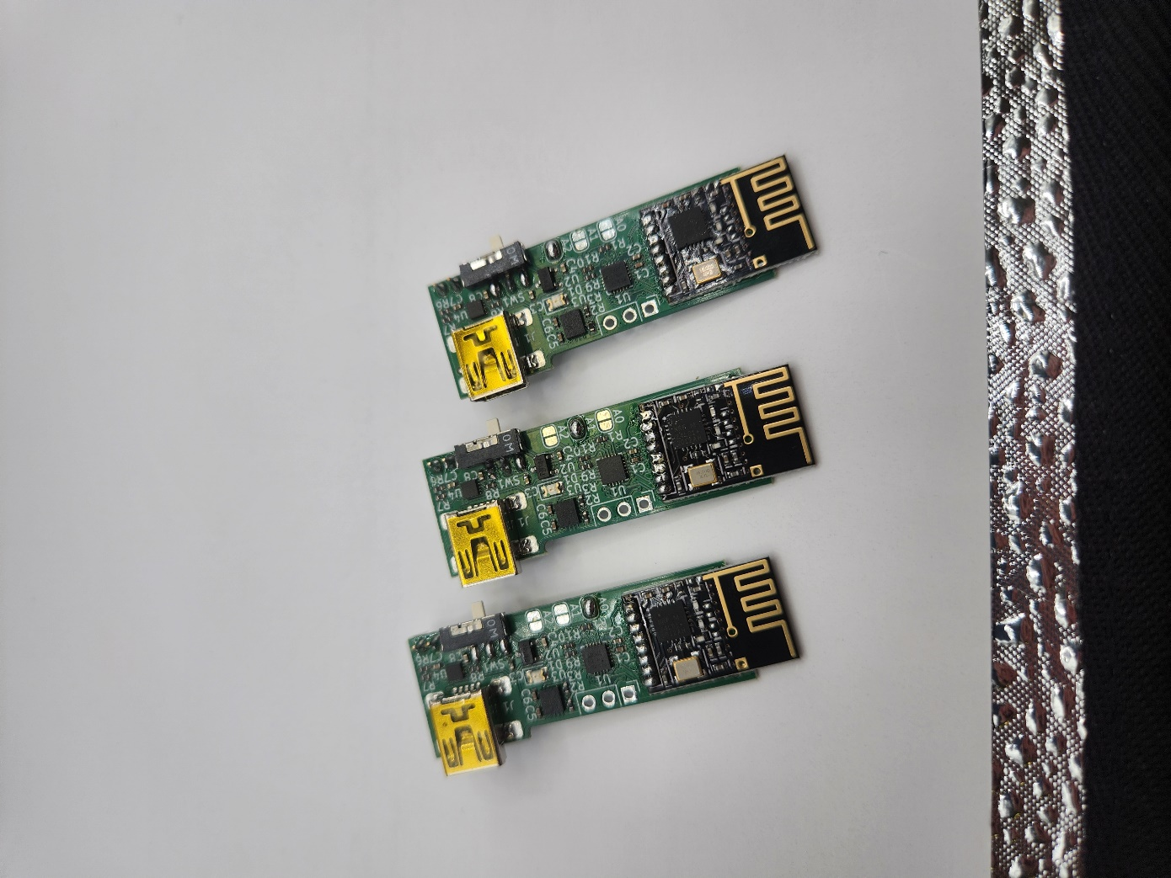The sensor’s number is assigned by placing a dab of solder on pads ‘A0’, ‘A1’, or ‘A2’ to assign it ‘sensor 1’, ‘sensor 2’, or ‘sensor 3’ respectively. For a complete set of sensors, assign one of each:

For sensor 1, add a blob of solder to connect the two pads labelled ‘A0’.

For sensor 2, add a blob of solder to connect the two pads labelled ‘A1’.

For sensor 3, add a blob of solder to connect the two pads labelled ‘A2’.

#### Step 5: Final Assembly

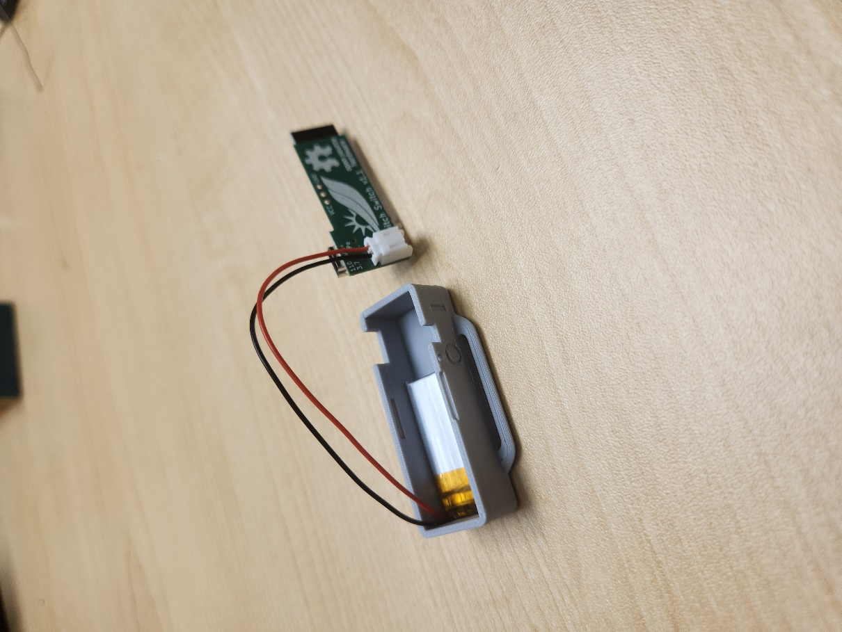Starting with the base of the **3D-printed case (C06)**, place the **battery (C05)** in the case. It should fit snugly. Place the battery on the side furthest from the cutouts for the slide switch and USB port, with wires going towards the edge of the case.

Connect the PCB to the battery.

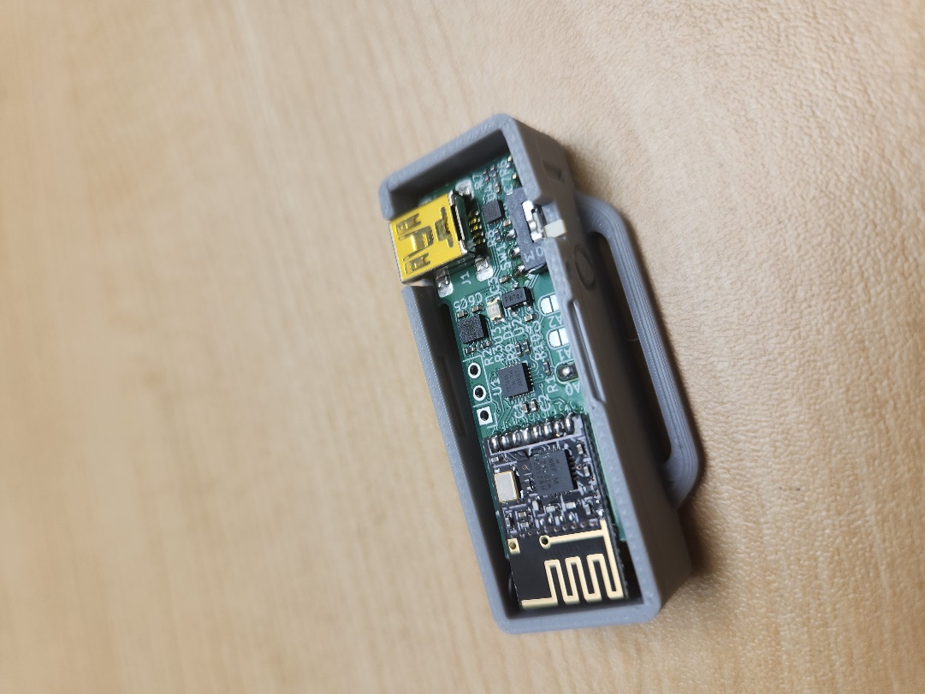Fold the wires into the case. Place the assembled PCB into the case overtop the wires; it should fit snugly. Ensure the mini-USB port and the power switch align with their respective openings in the 3D-printed case.

Snap the lid of the 3D-printed case into place. It will only fit one way. **Ensure the sensor number matches the number on the 3D-printed lid:**

* A0 = Sensor 1 Cover **(C07)**
* A1 = Sensor 2 Cover **(C08)**
* A2 = Sensor 3 Cover **(C09)**

**Repeat for all three sensors.**

Your Twitch Switch Sensors are now assembled!

## Part D: Build Programmer for Flashing Sensor Firmware

### Part D: Components

|  |  |  |  |  |  |  |  |  |
| --- | --- | --- | --- | --- | --- | --- | --- | --- |
| **D01** | CP2102 Programmer | QTY 1 | **D02** | 1N4002 Diode | QTY 1 | **D03** | Solderless Breadboard | QTY 1 |
|  | | |  | | | TW-E40-510 Twin Industries, Breadboard, Solderless, 83.82mm x 54.356mm | | |
| **D04** | 5 Pin Female to Male Dupont Cables  (if not included with programmer) | QTY 1 | **D06** | 2 Pin Male to Male Dupont Cables | QTY 1 |
| 1953 | | | 1956 | | |

### Part D: Programmer Assembly Steps

#### Connection Diagram

The following diagram shows how to where to place the components in the breadboard, this will then be broken down step by step in the sections below.

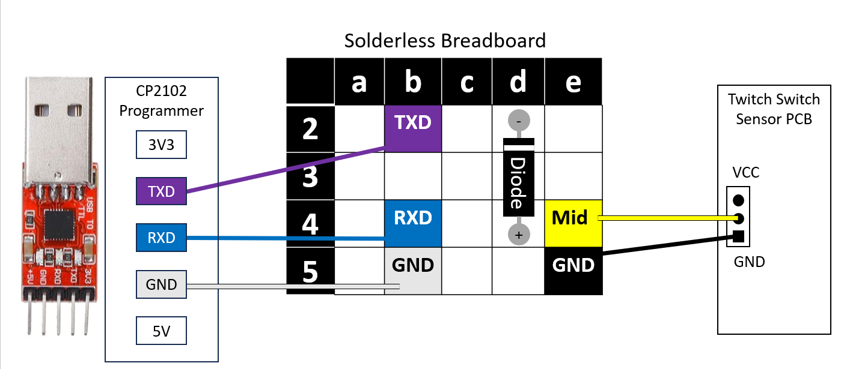

#### Step 1: Connect the CP2102 Programmer to the Breadboard

Using female to male Dupont wires, connect the CP2102 Programmer to the solderless breadboard. The female end will fit onto the programmer, and the male end will insert into the breadboard.

* 1. Connect GND from programmer to position b5 on breadboard.
  2. Connect TXD from programmer to position b2 on breadboard.
  3. Connect RXD from programmer to position b4 on breadboard.

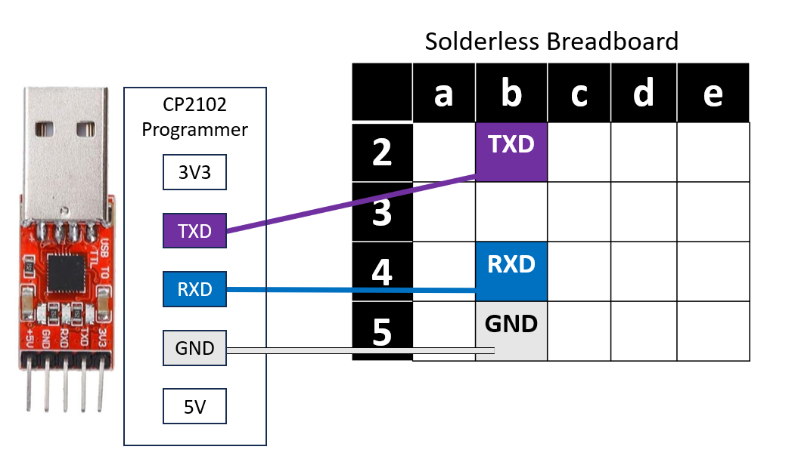

#### Step 2: Insert Diode into Breadboard

Take the Diode and bend into a U shape. Take the end of the diode on the side with the white line and push it into position d2 and the other end into position d4.

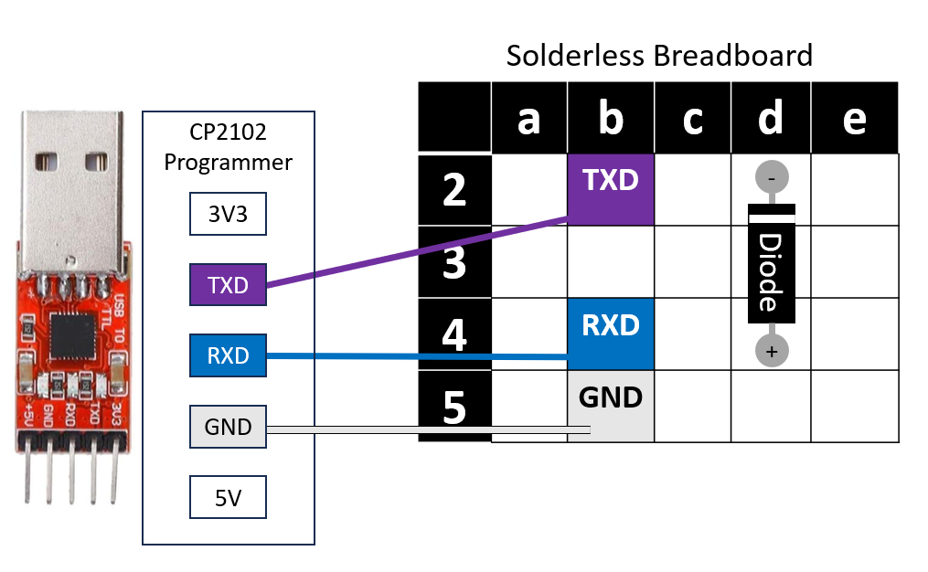

#### Step 4: Connect Breadboard to Sensor PCB

Finally, connect the breadboard to the Twitch Switch Sensor PCB using male to male Dupont wires. On the sensor, you will just be placing the wires inside the contacts, and then while programming will hold them in place.

Connect one wire from position e5 on the breadboard to the square ground (GND) pin on the sensor (Shown here in black)

Connect the other wire from position e4 on the breadboard to the middle pin on the sensor (shown here in yellow).



#### Programmer Assembled

This is what the assembled programmer should look like, just with the wires in slightly different positions on the breadboard.

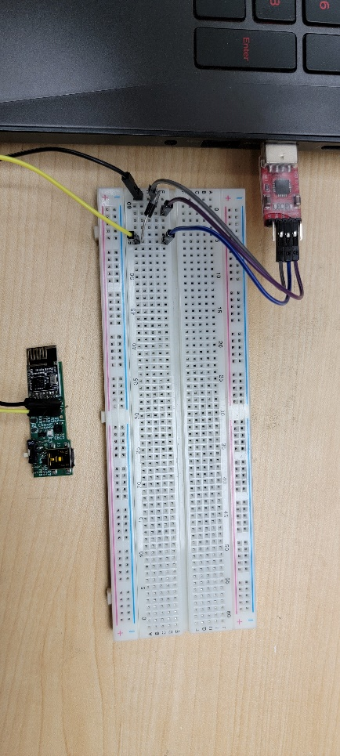

#### Programmer Usage Diagram

While using, you will connect the CP2102 Programmer to a PC. The below diagram demonstrates all connections while in use.

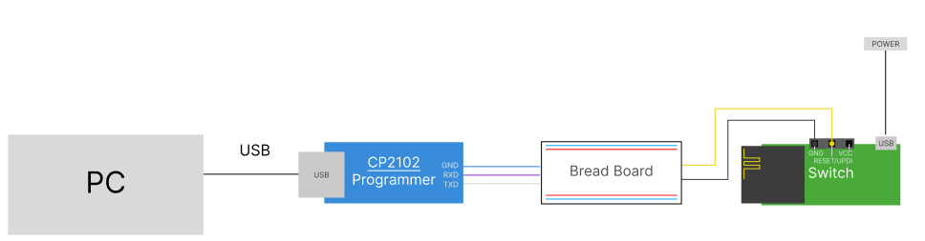

## Part E: Flashing Firmware to Sensors

### Part E: Components

|  |  |  |
| --- | --- | --- |
| **E01** | Assembled Twitch Switch Sensors | QTY 3 |
|  | | |

### Part E: Tools

* Computer with Arduino IDE to flash firmware
* Assembled Programmer from Part D
* Optional: USB Mini Cable - if programming before assembly

### Part E: Sensor Firmware Flashing Steps

#### Step 0: Remove Sensors from Enclosure

If your sensors are fully assembled, remove the PCB from the 3D printed enclosure so you can access the PCB.

#### Step 1: Setup Arduino IDE on Computer

1. Download Arduino IDE for your operating system at <https://www.arduino.cc/en/software>
2. Install the Arduino IDE.

#### Step 2: Arduino IDE v1.8.x Instructions: Setup Arduino IDE for megaTinyCore Board

If your Arduino IDE is 1.8.x, for example 1.8.19, use the following instructions. If your Arduino IDE is a version prior to 1.8.13, we recommend updating to 1.8.13.

1. Open Arduino IDE.
2. Click on **File -> Preferences**.
3. Locate the text field that says **Additional Boards Manager URLs** beside it.
4. Copy and paste the following link into the field as a new line: <http://drazzy.com/package_drazzy.com_index.json>
5. Click on **OK.**
6. Restart the Arduino IDE.
7. Open the **Boards Manager** option from the **Tools-> Board-> Boards Manager...,**
8. **Search for “megaTinyCore” and select “megaTinyCore” by Spence Konde.**
9. **Click Install to install the board.**

#### ****Step 3a: Confirm Setup for megaTinyCore Board****

1. Open Arduino IDE.
2. Select **Tools -> Board -> Mega Tiny Core -> ATtiny 3226/3216/1626/1616/1606**…
3. If you don’t see Mega Tiny Core in the menu, proceed to step 3b.

#### Step 3b: Installing megaTinyCore Boards Workaround

**Only complete the following if the Mega Tiny Core boards did NOT install correctly after checking in Step 3a.** This will likely be the case if using Arduino IDE version 2.x (for example 2.3.2).

You can also find installation instructions here, under “Manual Installation” <https://github.com/SpenceKonde/megaTinyCore/blob/master/Installation.md>

1. Download megaTinycore.zip from:

<https://github.com/makersmakingchange/Twitch-Switch/raw/36d1af43d22eaffc68675e05526d258241ae89fc/Build_Files/Firmware_Files/Library/megaTinyCore.zip>

1. Unzip the contents of megaTinyCore.zip to the following directory on your PC:  
   %LOCALAPPDATA%\Arduino15\packages
2. Restart Arduino IDE.
3. Confirm megaTinyCore is now installed by repeating Step 3a.

#### ****Step 4: Install Libraries****

1. Go to **Tools -> Manage Libraries…,** search for “rf24” and install the library “RF24” by TMRh20. Install version 1.4.8 or newer.

#### Step 5: Setup Local Code Directory

1. Download the Firmware_Files from the GitHub Repository:  
   <https://github.com/makersmakingchange/Twitch-Switch/raw/main/Build_Files/Firmware_Files/TwitchSwitchFirmware.zip>
2. Extract / unzip the folder “TwitchSwitchFirmware” to a known location.

#### Step 6: Setting up Programmer

1. Plug in the CP2102 programmer into the PCs USB port. You should hear the “connection” sound on your PC.
2. Note: The CP2102 programmer is very finicky and disconnects easily. Ensure it remains plugged in for the duration of programming.
3. Determine which COM port to use, since the COM for the programmer doesn’t have a name in the IDE,
   1. Open Windows Device Manager to determine the COM port.
   2. With the CP2102 programmer plugged in, look for **CP210x USB…** programmer as shown in the screenshot below.
   3. Note the COM port in brackets. This is the COM port to select in the Arduino IDE.

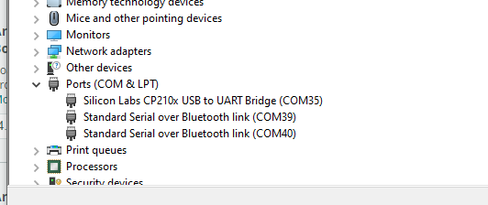

#### Step 7: Upload the Code to the Sensors using the Programmer

1. Open TwitchSwitchFirmware.ino with Arduino IDE.
2. **Select ATtiny 3226/3216/1626/1616/1606 from Tools -> Board -> Mega Tiny Core**
3. Click on **Tools -> Chip** and select **ATiny1616**
4. Click on **Tools -> Programmer** and select **SerialUPDI - SLOW: 57600 baud**
5. Select the correct port from **Tools -> Port** menu.
6. Place the wires from the programmer in the respective holes on the sensor: purple on the left hole (GND, square contact), and yellow in the middle hole.



1. Ensure the sensor has power, either through the battery with the switch slid to the “on” position, or by plugging the sensor into your PC with a mini USB cable.
2. Select Sketch -> Upload Using Programmer (or press CTRL + Shift + U)
3. Press and hold the wires from the programmer to the contacts in the sensor.
4. To confirm the upload is complete and was successful, you should see the following:

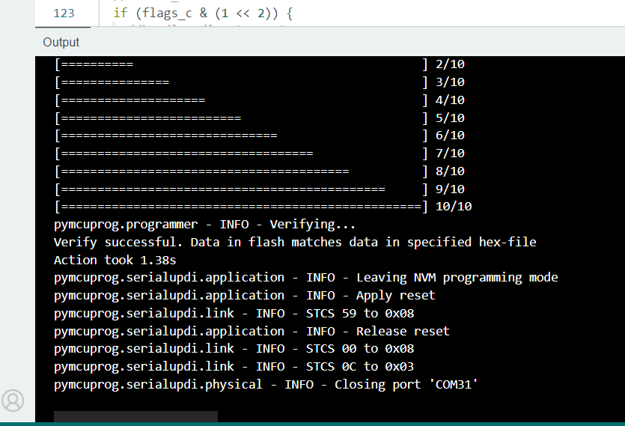

# Testing

## Required Components for Testing

* Assembled Twitch Switch Controller
* Assembled Twitch Switch Sensors (3)
* Micro USB Cable
* Mini USB Cable (for charging sensors)
* 3.5 mm cable (male to male)

## Testing the Twitch Switch

### Testing Mode LED and Device Power

1. Slide the power switches on each sensor to the on position.
2. Slide the power switch on the controller to the on position.
3. The LED will blink purple, then change colour to indicate the current mode.

### Testing 3.5 mm Jacks

Test the 3.5 mm jacks using a Switch Tester (or other switch-adapted item you possess).

1. Slide the power switches on each sensor to the on position.
2. Slide the power switch on the controller to the on position.
3. Using a male-to-male audio cable, plug one end of the cable into the Twitch Switch switch jack for sensor 1 and the other end into the Switch Tester.
4. Move sensor 1, and check that the Switch Tester is activated.
5. Repeat steps 3 and 4 for sensors 2 and 3.

### Test USB Connection

1. Slide the power switches on each sensor to the on position.
2. Slide the power switch on the controller to the on position.
3. Connect the controller to a host device (such as a PC) using the micro USB cable.
4. Confirm that the Twitch Switch functions while plugged in via UCB and can send mouse/keyboard commands. Refer to User Guide for descriptions of each mode.

### Test Bluetooth Connection

1. Slide the power switches on each sensor to the on position.
2. Slide the power switch on the controller to the on position.
3. On a Bluetooth compatible device, search for new devices to pair.
4. Select “Twitch Switch”
5. Confirm that it pairs successfully and can send mouse/keyboard commands. Refer to User Guide for descriptions of each mode.